
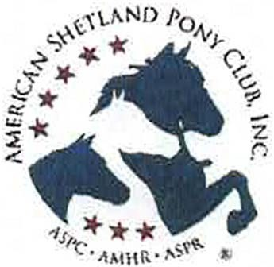

ASPC - AMHR - ASPR

NATIONAL AREA I SHOW 2026
HOSTED BY:

DELMARVA MINIATURE HORSE CLUB

MAY 29-31, 2026
DELAWARE STATE FAIRGROUNDS. HARRINGTON, DE

Start Time:
Friday-8:00am (EST) Saturday-8:00am Sunday-8:00am
Entry Deadline - MAY 15, 2026

Judge
RONALD BARTHOLOMEW

Steward
TROY MURRELL

Show Manager:
DONNA PHILLIPS
2953 Mackville Road, Harrodsburg, KY 40330
859-265-1196 (cell) highmountainqh@yahoo.com INFO AT: highmountainequestrianevents.com

Location: Delaware State Fairgrounds
18500 S Dupont Highway Harrington, DE 19952

Sponsored by: Delmarva Miniature Horse Club

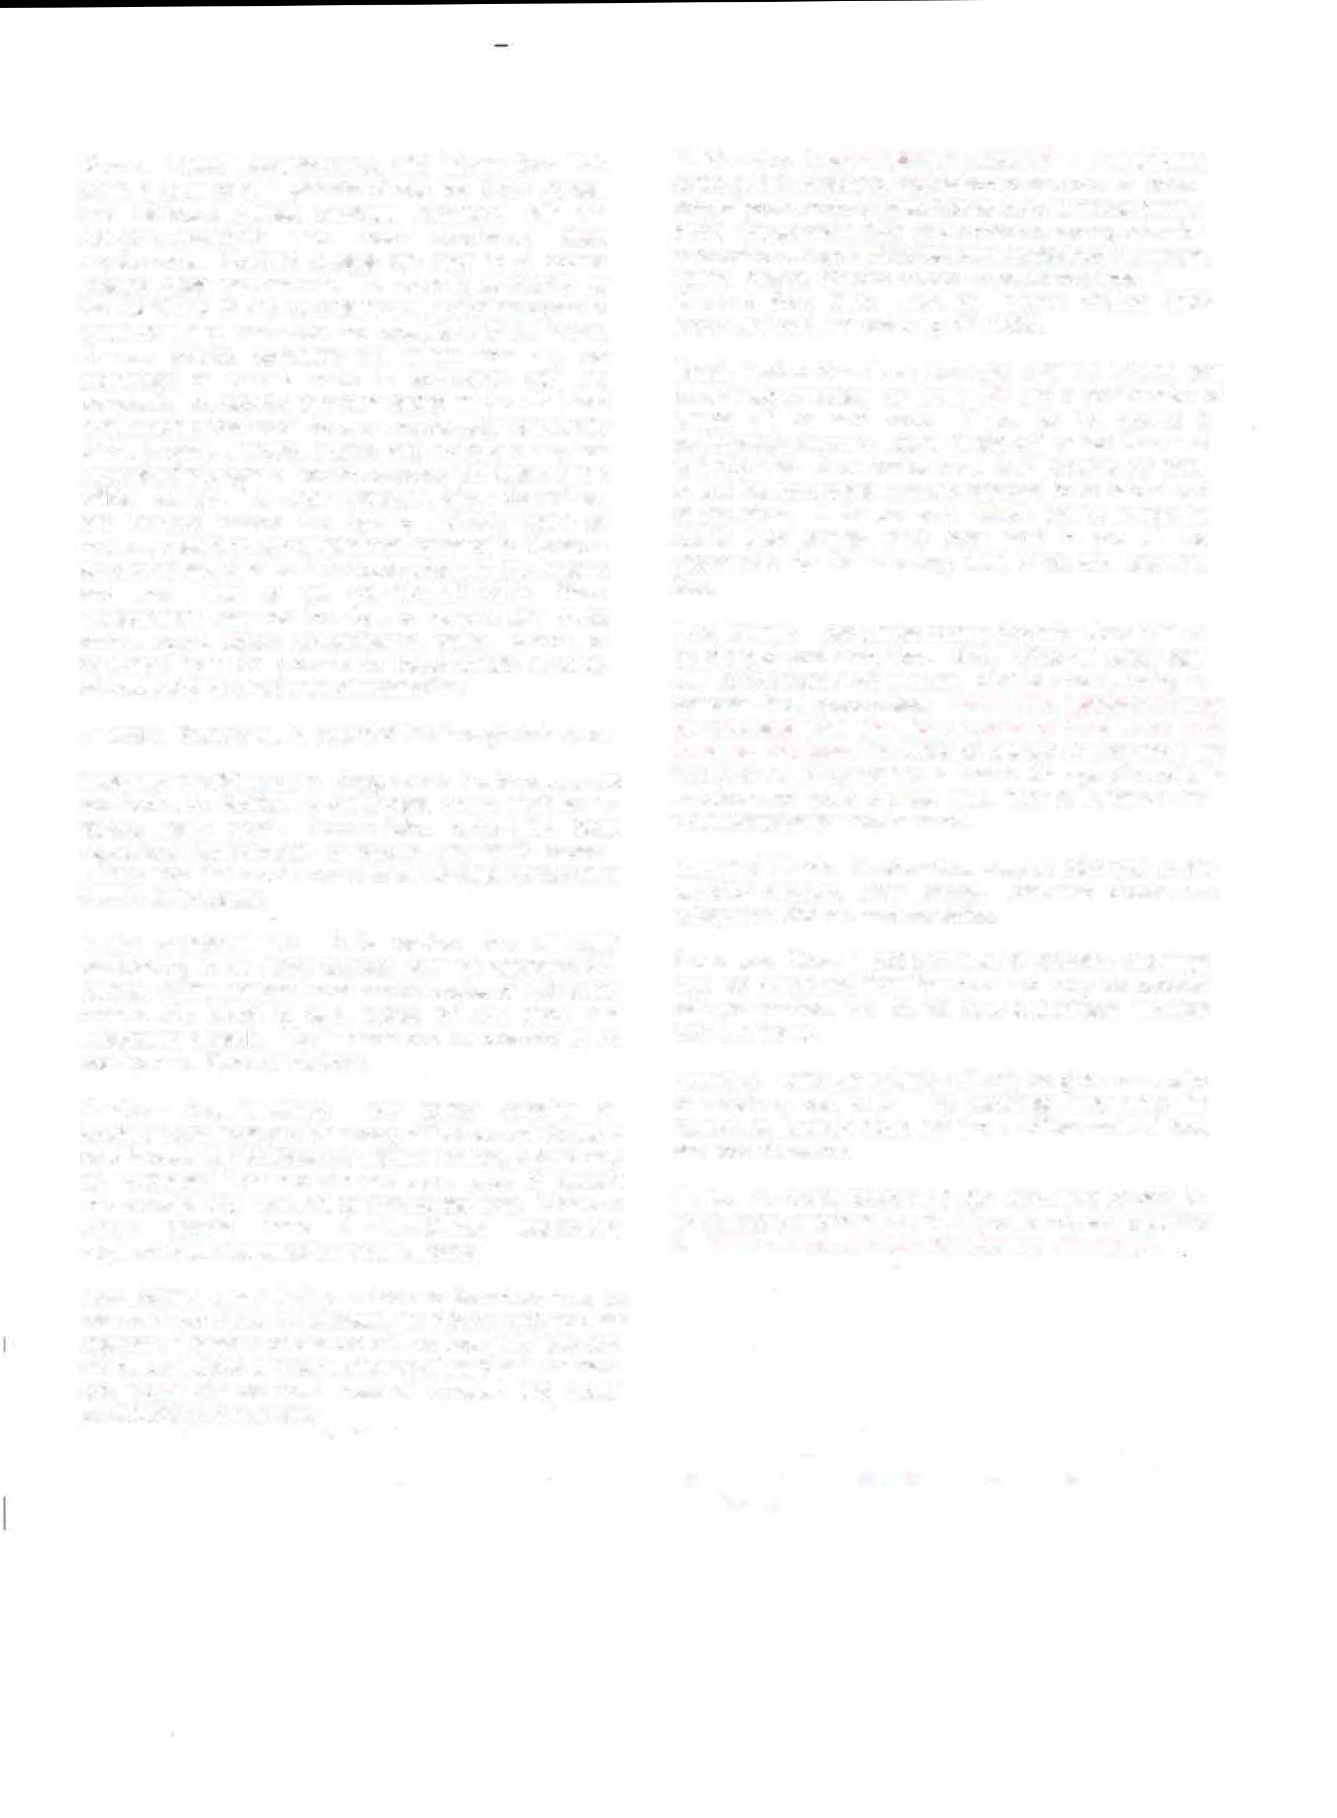
General Rules, Requirements, and Information: This show is open to all registered Shetlands, Show Ponies, and Miniature Horses currently registered with the ASPC/AMHR/ASPR who meet sanctioned class requirements. Non-rated classes are open to all equine meeting class requirements. This show is sanctioned by the ASPC/AMHR and by entering; all exhibitors agree to abide by the current rules and regulations of the ASPC. Owners, agents, exhibitors will refrain from any act committed or remark made in connection with the competition considered offensive and/or made with intent to influence or cast aspersions on the character or integrity of the judging. Owners, agents, and exhibitors may not approach the judges without the express permission of the official steward. The Show Manager, Show Committee, and Steward reserve the right to arbitrarily settle all matters, questions, and differences incidental to this show
so long as said decision is in accordance with the by-laws and show rules of the ASPC/AMHR/ASPR. Show Management reserves the right to remove any horse owner, agent. stable representative, trainer, groom, or exhibitors from the grounds for inappropriate behavior without being held liable for compensation.
Awards: Ribbons will be awarded first through sixth place.
Coggins / Health papers: Coggins and Health papers may be required at the facility. Please note that requirements for out of state horses may differ from in-state horses. Flu/Rhino shots are strongly suggested. Please follow current DE State regulations and requirements for coggins and health papers. Consult with your veterinarian, and be sure to travel with the documents required by the states you are traveling through and showing in. Please have health forms available for inspection.
Youth Requirements: It is required that all youth participating in all riding classes wear an approved SEI helmet. Youth members must provide copies of their youth membership cards to earn points towards show and association awards. Youth cards can be obtained at no cost from the Steward the show.

Amateur Requirements: Any person entering an amateur class must provide a copy of their current Amateur card in order to participate In Amateur classes. A card may be purchased from the steward upon proof of current membership and payment of appropriate fees. Miniature Horse classes have specific Amateur/Owner relationship requirements. Please consult your rulebook.

Add/Scratch Class Policy: Adds and Scratches must be recorded with the show secretary 10 classes prior to class changes. Transfers of classes will not incur late fees and will be considered a "wash". Change of handler in Amateur and Youth classes must meet all Amateur and Youth participation requirements.
Entries Due: All entry forms, copies of BOTH sides of registration paper-s of each horse, copy of youth and/or Amateur cards, copy of measurement cards if measured in 2026 and a check or money order for payment of all appropriate fees sent to the Show Manager, Donna Phillips.

Checks made payable to: Delmarva Miniature Horse Club (DMHC).

Mail to: Donna Phillips, 2953 Mackville Road, Harrodsburg, KY 40330. Entry deadline is May 15TH.

Email, Text or Facebook Message Entries: Entries may be emailed or texted by May 15TH and a confirmation of entries will be sent back. If you do not receive a confirmation within 24 hours please call or text Donna at 859-265-1196. Once entries have been received by email or text the appropriate fees are expected to be paid at end of the show. If for unknown reason you're unable to attend after entries have been sent in you will be responsible for the following: stall, office and shavings fees.

Post Entries: Late entries postmarked after May 15th will be charged post entry fees. Show office will close each day approximately 30 minutes prior to show starting to compete final preparations. Adds and Scratches must be recorded with the show secretary 10 classes prior to class changes. Transfers of classes will not incur late fees and will be considered a "wash". Change of handler in Amateur and Youth classes must meet all Amateur and Youth participation requirements.
Returned Check: All show fees must be paid prior to any exhibitor numbers being issued. Returned checks are subject to a $35 returned check fee.
Shavings: Straw is not permitted for bedding. Shavings may be purchased from the club and may be ordered with your entries. You do not have to purchase shavings from the facility. No shavings are included with the stall fee.
Refunds: Entry fee refunds will only be given on receipt of veterinary certificate. The certificate must state the reason the horse(s) could not show. Office and stall fees are non-refundable.
Stalls: Per facility policy ANY stall used must be paid for. Do not store or groom in a stall if you do not wish to pay for it. Stalls will be available for check In on Friday-noon. To inquire about early arrival contact Nina OBryan at
302-670-2282
There will be an $18.00/stall fee for cleaning stalls unless they are cleaned by the exhibitor before leaving the grounds.
No horses permitted on trailers overnight.
Under no circumstances may any items be stapled, nailed or tacked to any stalls. Only tape or push pins may be used.
Stalls have sliding doors and bars. Things may be hung with wire, chain or string only. No more than 2 horses per stall. 2 year old and older stallions must be stalled separately.
No washing of animals anywhere except in wash racks.
Food: There will be a food vendor on site serving breakfast, lunch and early dinners, plus snacks.
There are also several fast food chains 5 minutes away and 2 family restaurants 5 minutes away.

Measuring: All horses must be measured by steward or present a valid measurement slip documenting measurement by an official Steward within 60 days or present a permanent measurement card showing a measurement in the year of 2026. Please have your registration papers available for identification. Measurement times will be posted. Measuring Thursday 5:00-7:00pm, one hour before show start time Friday, Saturday and Sunday and as needed throughout the show when steward isn't needed in the ring.
Gate Policy: It is the owner/handler/exhibitor's responsibility to be on time for classes. Announcements to barn area are a management courtesy. A TWO-MINUTE Gate will be observed. Timing will begin when the first horse enters the gate. Exhibitors are encouraged to have the equipment and/or equine in the warmup area to reduce tack change delays. Tack changes are limited to seven minutes. If you need a tack hold, please tell the Gate Person.
Dog Policy: All dogs MUST be confined or on a leash at ALL times. Al no time will excessively barking or running loose be tolerated. All dogs must be current with health requirements.
Emergency Information: Local emergency 911 for human emergency care. Contact information for Emergency Farrier & Veterinarian will be posted at the show throughout the barns.
Camping Reservations: Reservations must be made thru the Delaware State Fairgrounds office. 302-398-3269. They are open M-F 9:00am-3pm. Or visit

DIRECTIONS:
From The North-Follow Route 1 South. Exit 97 to Route 13 South to Harrington to Delaware State Fairgrounds on the right just past the railroad tracks.
From Chesapeake Bay Bridge: Follow Route 50 East to 404 East to Denton. Once in Denton, exit on route 313 North (McDonalds will be on your right), go to blinking light intersection at Oil Cotu. make a right and follow signs to Harrington and the Delaware State Fairgrounds.

Motel Information:

SUPER 8
Route 13 Harrington, DE
(302) 398-4206
Motel is about 2 miles north of show grounds

QUALITY INN AND SUITES (was Americinn)
Route 13
Harrington, DE (across from the fairgrounds) Pool, sauna, free continental breakfast.
Mention that you are with the horse show for a special rate.

HOLIDAY INN EXPRESS
7271 S. Dupont Highway Harrington, DE (302) 398-8800

There are also local Air BNB's available. Search in Harrington,

delawarestatefair.com
t DE or Milford, DE.

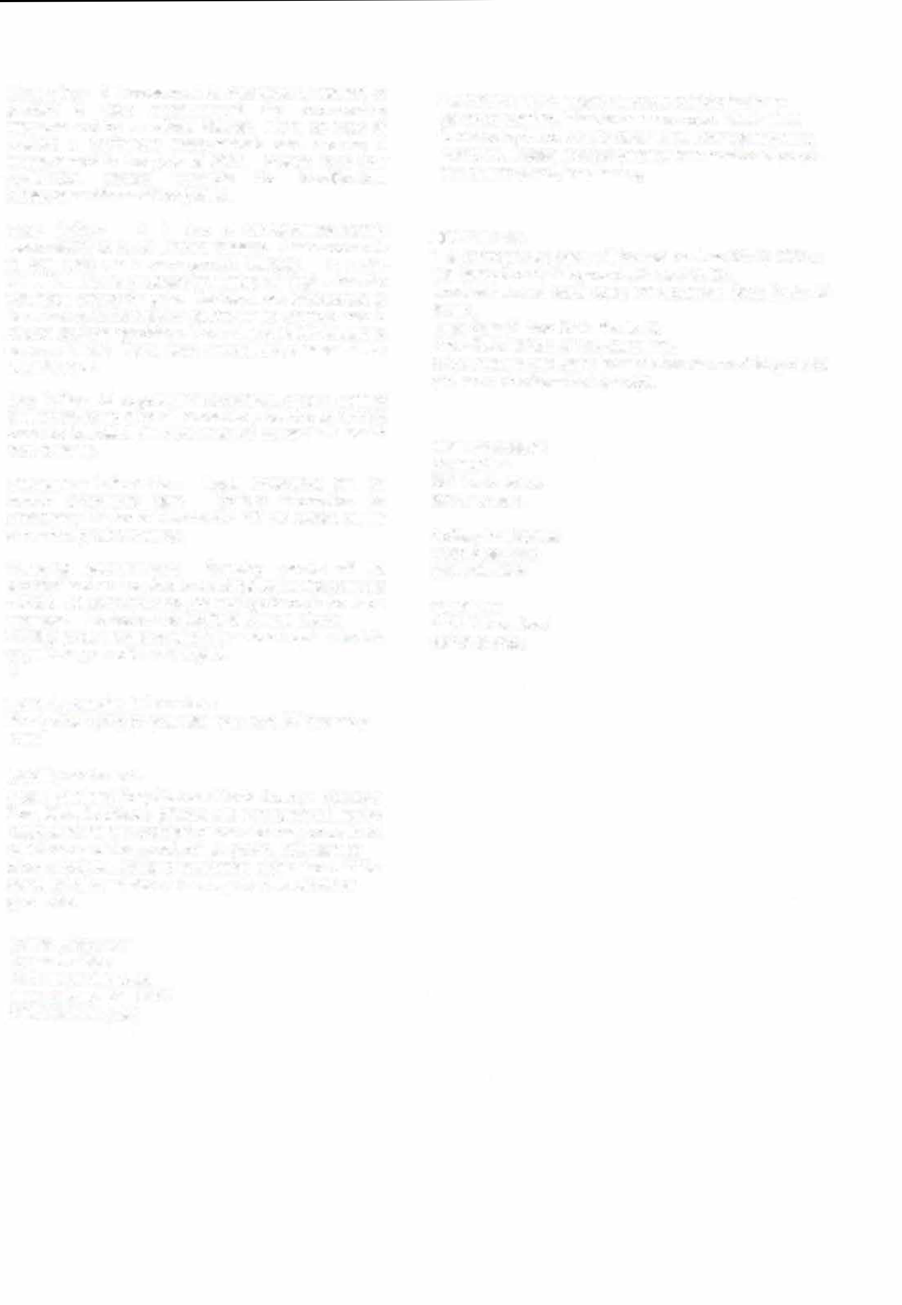
All campers will be in campgrounds or in exhibitors parking lo south of arena. All ship ins will be in Exhibitors parking lot.
Hooks ups and PA system will be there. No campers parked around the barn or near office or across from the Schabinger Pavillion.

Liability statement:
Delaware State Fairgrounds, Delmarva Miniature Horse Club, its officers, officials and employees will not be responsible for any accident or loss which may occur to an exhibitor, spectator, guest, driver, groom, attendant. or other employee, animal or equipment at this show. This shall be a condition of entry to this show or grounds.

Show Manager Donna Phillips
2953 Mackville Road
Harrodsburg, KY 40330
859-265-1196 (cell)

