
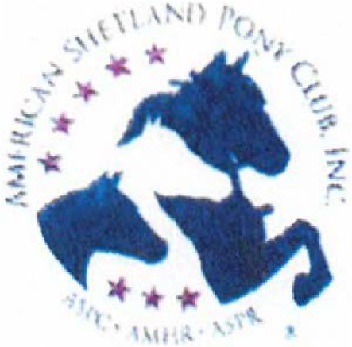

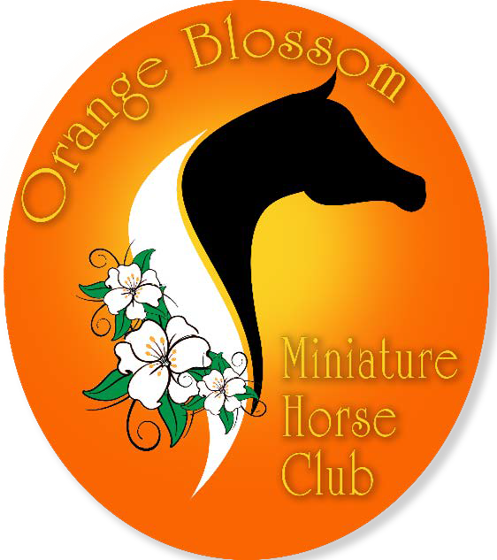
ASPC~AMHR

ORANGE BLOSSOM MINIATURE HORSE CLUB-SPRING ROUND-UP

JUNE 28, 2026
FALLS CREEK FARM 368 BAILEY ROAD
MOOSUP, CT 06354

Start Time
SUNDAY-8:00am

Entry Deadline -JUNE 12, 2026

Judges

PAM ALLEN NATIONALS JUDGE
SANDY CROOTE

Steward
ROBBY MCCARTHA

Show Manager:
DONNA PHILLIPS
2953 Mackville Road, Harrodsburg, KY 40330
859-265-1196 highmountainqh@yahoo.com

PIZZA PARTY AND MOVIE NIGHT-FRIDAY EVENING SPONSORED BY:TRIPLE CROWN FEEDS
BBQ DINNER SATURDAY EVENING-$20.00/PLATE


This show is open to all registered Shetlands, Show Ponies, and Miniature Horses currently registered with the ASPC/AMHR/ASPR who meet sanctioned class requirements. Non rated classes are open to all equine meeting class requirements. This show is sanctioned by the ASPC/AMHR and by entering; all exhibitors agree to abide by the current rules and regulations of the ASPC. Owners, agents, exhibitors will refrain from any act committed or remark made in connection with the competition considered offensive and/or made with intent to influence or cast aspersions on the character or integrity of the judging. Owners, agents, and exhibitors may not approach the judges without the express permission of the official steward. The Show Manager, Show Committee, and Steward reserve the right to arbitrarily settle all matters, questions, and differences incidental to this show so long as said decision is in accordance with the by-laws and show rules of the ASPC/AMHR/ASPR. Show Management reserves the right to remove any horse owner, agent, stable representative, trainer, groom, or exhibitors from the grounds for inappropriate behavior without being held liable for compensation. All horses must be measured by the AMHR Steward or present a measurement slip documenting measurement by an official AMHR steward within the last 60 days or a permanent card that has been validated in the year 2026 along with valid AMHR registration papers. Youth and /or amateur numbers must be provided to show management.
PREMI UMS: Ribbons will be awarded for first through sixth place in each class, Grand/Reserve Champions and Champion/Reserve horses.

GENERAL RULES
Evidence of any inhumane treatment to a horse in or out of the show ring will result in disqualification of that horse and that exhibitor for the balance of the show, as well as all of that horse's and exhibitor's points, ribbons, trophies, plus all entry, stall, and office fees being forfeited.
Dogs must be on a leash.
Trash: Trash cans are available on the grounds and near the arena. Please dispose of your trash properly.
Members of NEMHS, exhibitors, representatives and spectators agree to conduct themselves professionally and utilize good sportsmanship at all times. Violators are subject to removal from the grounds.
Dress Code: Absolutely no torn jeans, sweat pants, shorts, t-shirts, tank tops or open toed shoes are allowed in the ring. This includes all ring personnel. Proper show attire will be worn by exhibitors in the ring at all times, including Championship and Grand classes. Please refer to your rulebook, especially for Showmanship classes.
Judge and Show Management Evaluations: Evaluation forms will be available in the show office to be completed on a voluntary basis.
Return Check Fee: There will be a $35.00 charge for any returned check by NEMHS.
Refunds: No refunds will be given on any office fees or stall fees. Refunds will only be given on receipt of veterinary certificate stating the reason the horse was unable to show. Substitutions will be accepted without penalty. This show will run rain or shine. There is an indoor arena.


ENTRIES
Please pre-enter if possible. Entries postmarked or emailed after the deadline are subject to an additional fee. Pre-entries must be accompanied by payment. Refunds will be made with a veterinarian's certificate or a physicians' letter. Please see refunds above.
Provided you have pre-entered, classes may be added on the day of the show without penalty.
Please take care to fill out the entry form completely and carefully, and include your signature and amateur/youth numbers where indicated.
A copy of both sides of your horses' AMHR/ASPC registration papers must accompany the entry form and be presented at measuring.
Youth and Amateur exhibitors must hold current AMHR Youth or Amateur cards, or may apply with the show steward the day of the show. Please include your youth and amateur numbers on the entry form, and enclose a copy of your current youth and amateur cards with your entry form. Amateurs must also sign the entry form where indicated. AMHR youth is an individual that has not attained eighteen years of age as of December l51 of the current competition year.
Gelding Status: It must be reflected on the registration papers in order for the horse to be shown in any AMHR classes.
Leased Horses: They must be on record with ASPC/AMHR. Include a copy of the lease authorization form, and indicate on your entry that the horse is leased.
Driving Horses: All driving horses are to be driven with a bit. NEMHS request that all Youth drivers wear an ASTM approved helmet. Helmets are required in youth roadster classes.
Stalls: No more than 2 horses per stall. Stallions over 2 years must be stalled separately. Pre-ordered shavings will be available for pick up when you arrive at the facility. You may bring your own shavings. Stall waste is to be dumped in designated areas only. Contact the show manager to make stall arrangements. Stalls are a minimum of 10' x 10'. Stalls will be available after 1:00pm on Thursday, June 25, 2026. Absolutely no early arrivals.
PA System: This is a courtesy provided by the facility. If it does not function, show management will work with the facility to ensure this service, but it is not guaranteed. We will be using a two-minute gate call. Please check in with the gate manager when arriving at the ring so that the show can continue at a steady pace. It is each exhibitor's responsibility to be at the gate on time. Should a tack change be required please request this at the gate at least five classes ahead of the needed time.
Concession Stand: There will be a concession stand at the grounds.
There will be a movie night for everyone on Friday evening. This will include a pizza party sponsored by Triple Crown Feed.
Saturday evening there will be a BBQ dinner fixed by the Oneco Fire Department. There will be a $20.00/dinner fee for this. You must sign up ahead of time for this. The meals are large so if you have two kids they can share one meal.
COOL: Special needs individuals are always welcome to participate in all AMHR shows. If special arrangements are needed please try to contact the Show Manager ahead of time, if possible.


CAMPING: There are sites available with water and electric. There are also dry camping sites available (no hookups). Sites available on a first com-first serve basis. There are no sewer hookups and no dump station at the facility.
Discounted fees: Discounted fees are for members of the New England Miniature Horse Society.

HEALTH REQUIREMENTS
Please follow current CT State regulations and requirements for coggins and health papersPlease note that the requirements for out-of-state horses may differ from in-state horses.Consult with your veterinarian, and be sure to travel with the documents required by thestates you are traveling through and showing in. Please have health forms available for inspection upon request. Consult with your veterinarian, and be sure to travel with the documents required by the states you are traveling through and showing in.

MEASURING
Measuring will begin Thursday 5:00pm-7:00pm. Then 1 hour before the show starts and by special request, whenever possible throughout the day. Show start time will be 8:00am.
Measuring will be conducted by the AMHR Show Steward. At the time of measurement, please have available your registration papers. All horses must be measured, present a valid 60 day pink slip or present a 2026 validated permanent measurement card before entering their first class.
Address: 368 Bailey Road, Moosup, CT 06354

Please be respectful of others and place trash in cans and scoop the poop!!
THANK YOU FOR SHOWING WITH NEMHS IN 2026!!

Details X

Moosup
0
Moosup

+-t 0.9mi

+-t
0.3mi Turn left onto Bailey Rd
Turn left onto Pond St

+-t 0.6mi
r+ 0.2mi Turn left
Turn right onto River St

700ft
+-t
Turn left onto Sterling Hill Rd

450ft
Turn right
r+

2.3mi ➔� 500ft
+-t
Turn left onto Sterling Hill Rd The destination is on your right

80ft Falls Creek Farm
+-t 8
Turn left onto Plainfield Pike 368 Bailey Rd, Moosup

1.7 mi
r+
Turn right onto Newport Rd

1.3 mi
r+
Turn right onto Woodland Rd

2:46.,
�1-1•

f ti:\
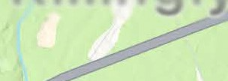

J Lake0
••
� Park �

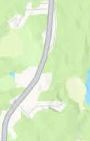
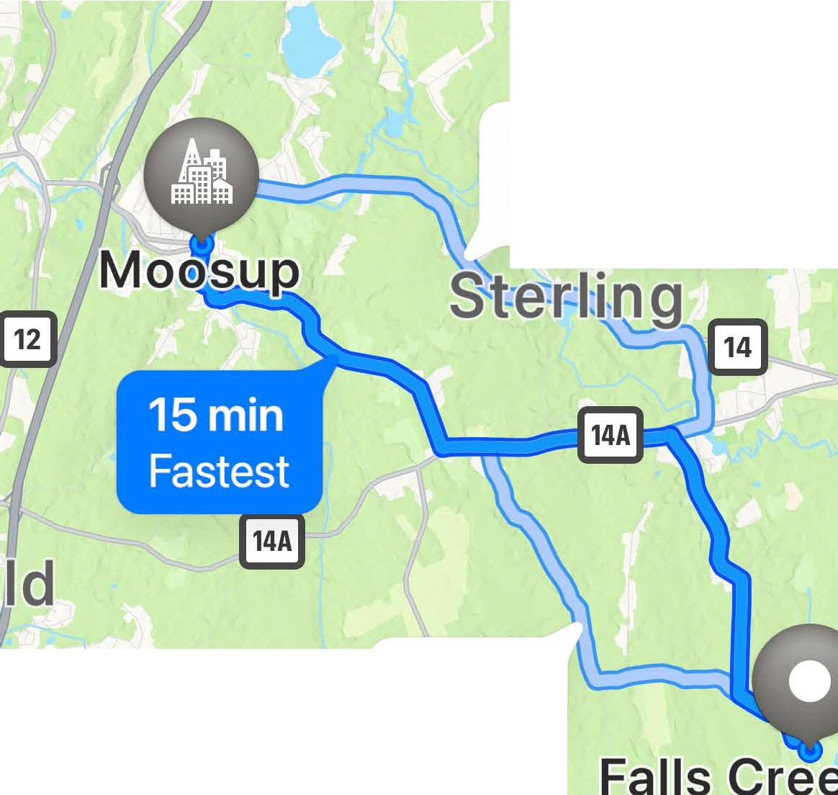
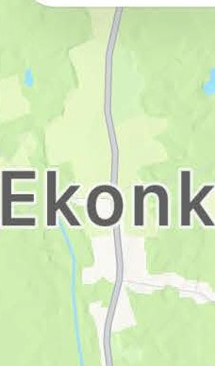

egan
16min
Fewer turns
15min
61°

- AQI 35e

Directions X

