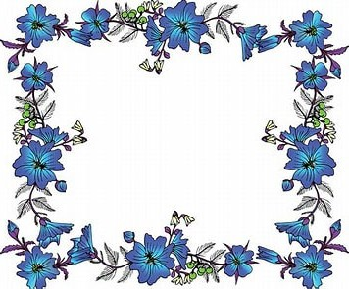
 | # |  | Deadline  MAY 15 |  | Total
Office Fee Per Horse |  |  | X $8.00
YOUTH CLASS FEE |  |  | $20.00
AMATEUR CLASS FEE |  |  | X $25.00
OPEN CLASS FEE |  |  | X $30.00
COOL CLASS FEE |  |  | X $20.00
STAKE CLASS FEE |  |  | X $30.00
Shavings |  |  | X $9.00 | Must be Pre-ordered
Stall/weekend  Stall cleaning fee if not cleaned by exhibitor |  |  | X 70.00  X $18.00
Show From Trailer/horse/day |  |  | X $30.00 | X horse X day
Camping must be arranged thru
fairgrounds 302-398-3269
Late Fee |  |  | $25.00/horse | X horse
Class $10.00 per class or
Sponsorship 6 classes for $50.00
Did you enclose a COPY of the following:  Registration Paper  Both Sides of Perm. Measurement Card Copy of Amateur &/or Youth Cards Entry Form Signed & Completed  Check or Money Order |  | For Office Use Only:  Date Received: Amount Enclosed: $ Check #:  MEMBER

NATIONAL AREA I SHOW HOSTED BY:
DELMARVA MINIATURE HORSE CLUB DELAWARE STATE FAIRGROUNDS 18500 S DUPONT HIGHWAY HARRINGTON, DE 19952
MAY 29-31, 2026

Name of Farm Contact Person Mailing Address

City State Zip
( )

Phone #

E-Mail Address
Please Stall with:

Make checks payable to: DMHC
Mail entries to: DONNA PHILLIPS, 2953 MACKVILLE ROAD,
HARRODSBURG, KY 40330
or email entries to: highmountainqh@yahoo.com

If you do not attend the show after mailing, emailing or texting entries you will be responsible for stall fees, office
fees, and shavings ordered.

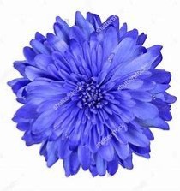
NATIONAL AREA I SHOW

Must enclose a copy of registration papers, amateur and youth cards and copy of measurement card if measured in 2026.

Show No.  (Office Use) | Name of Horse | Exhibitor Name (s) | Class Number  (One class number per box) |  |  |  | Reg. No. | Date of Birth | Sex | Height  (Office Use) | Registered Owners Names and City & State
 |  | 1)
 |  | 2)
 |  | 1)
 |  | 2)
 |  | 1)
 |  | 2)
 |  | 1)
 |  | 2)
 |  | 1)
 |  | 2)
 |  | 1)
 |  | 2)

This form must be signed in order to participate in the show. I hereby enter these horses in the classes listed above. By so entering, I agree to abide by and be bound by all rules and regulations of Delmarva Miniature Horse Club and Delaware State Fairgrounds. I agree to hold harmless the managers/staff and sponsors of the show from all liability in case of accident, theft, injuries or loss in any way associated with my participation in this event. My signature is proof that I have read, understand, and agree to accept this statement.

Signature of Exhibitor Signature of Exhibitor Signature of Parent or Legal Guardian

I certify that I am an amateur or youth as recognized by the rules of the AMHR – ASPC – ASPR.

Signature of Amateur & Am. # Signature of Amateur & Am. # Signature of Youth and Youth #

