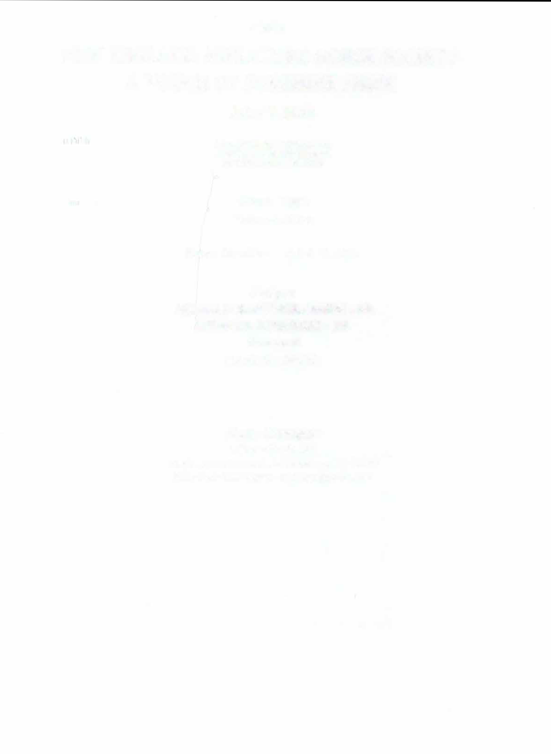
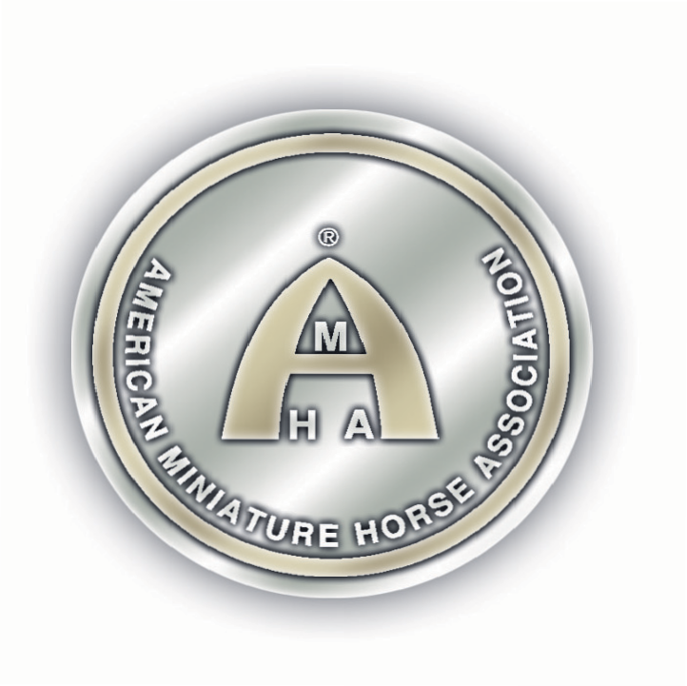
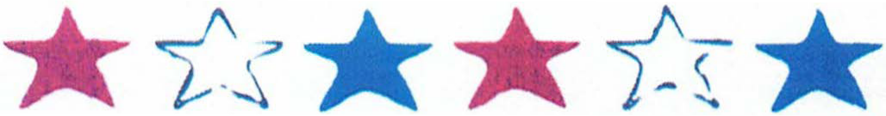
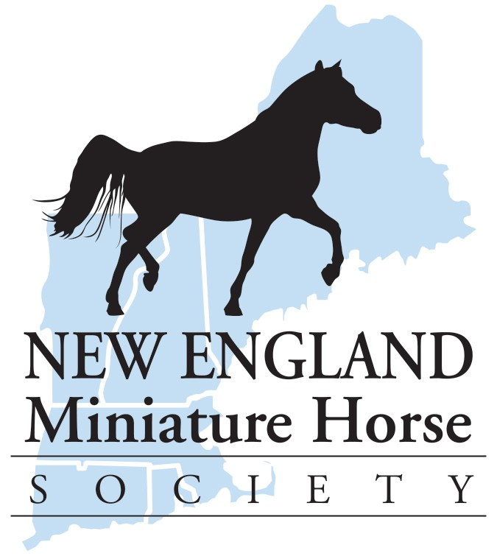
AMHA

NEW ENGLAND MINIATURE HORSE SOCIETY SPRING ROUND UP
JUNE 26, 2026
FALLS CREEK FARM 368 BAILEY ROAD
MOOSUP, CT 06354

Start Time

FRIDAY-8:30AM

Entry Deadline -JUNE 12. 2026

JUDGES
DAVID PHILLIPS-SENIOR JUDGE-NY-WORLD JUDGE DENNIS SIENICKI-SENIOR-NJ-NATIONALS JUDGE

STEWARD
ROBBY MCCARTHA

Show Manager:
DONNA PHILLIPS
2953 Mackville Road. Harrodsburg, KY 40330
859-2 65-l 196
highmountainqh@yahoo.com
Website: highmountainequestrianevents.com

PIZZA PARTY AND MOVIE NIGHT-FRIDAY EVENING SPONSORED BY: TRIPLE CROWN FEEDS
BBQ DINNER SATURDAY EVENING-$20.00/PLATE


This show will be conducted under the rules and regulations set forth in the current AMHA Official Rule Book. Knowledge of AMHA Show Rules and Regulations, as outlined in GR-010, as well as the requirements for each class entered, is each exhibitor's responsibility. The show is open to all AMHA registered horses. All horses participating in AMHA classes must be registered with AMHA.
PREMIUMS: Ribbons will be awarded for first thru sixth place in each class. Also, Grand and Reserve Grand Champions

Evidence of any inhumane treatment to a horse in or out of the show ring will result in disqualification of that horse and that exhibitor for the balance of the show, as well as all of that horse's and exhibitor's points, ribbons, and trophies will be forfeited. All entry, stall and office fees will be forfeited as well.
1.
All dogs must be on a leash.
2.
Trash cans will be available around the facility. Please dispose of your trash properly
3.
Dress Code: Absolutely no torn jeans, sweat pants, shorts, t-shirts, tank tops or open toed shoes are allowed in the ring. This includes all ring personnel. Proper show attire will be worn by exhibitors in the ring at all times, including Championship and Supreme classes. Please refer to your rulebook, especially for Showmanship dress rules.
4.
Judge evaluation forms will be available in the show office, and may be completed on a voluntary basis. Exhibitors, staff, etc. are encouraged to fill these forms out.
5.
Return check fee: NEMHS will charge a fee of $35.00 for returned checks.
6.
Refunds : No refunds will be given on any office fees or stall fees. Refunds will only be given on receipt of veterinary certificate stating the reason the horse was unable to show.
7.
Substitutions will be accepted without penalty. This show will run rain or shine. There is an indoor arena.
COOL: Special needs individuals are always welcome to participate in all AMHA shows. If special arrangements are needed please try to contact the Show Manager ahead of time if possible. This show is open to all exhibitors regardless of mental or physical abilities
8.
- Please pre-enter if possible. Entries postmarked or emailed after the deadline are subject to an additional fee. Pre-entries must be accompanied by payment. Refunds will be made with a veterinarian's certificate or physicians' letter. Please see refunds above
- Provided you have pre-entered, classes may be added on the day of the show without penalty.
- Please take care to fill out the entry form completely and carefully, and include your signature and amateur/youth #'s where indicated. If you are showing as a youth or amateur and your name is not on the registration papers' of the horse, please indicate on the entry form what your relationship is to the owner of the horse.

- A copy of both sides of your horses' AMHA registration papers MUST ACCOMPANY THE ENTRY FORM, and BE PRESENTED AT MEASURING. Or you must show proof from AMHA that registration is pending. !They will send you a form on request.) If you have not received this proof, you must call the show manager at least 1 week before the show so that the manager can confirm pending status with the AMHA office.


YOUTH AND AMATEUR: Exhibitors must hold current AMHA Youth or Amateur cards, or may apply with the show secretary for"pending" status on the day of the show Please include your youth and amateur numbers on the entry form, and enclose a COPY OF YOUR CURRENT YOUTH AND AMATEUR CARDS WITH YOUR ENTRY FORM. Amateurs must also sign the entry form where indicated. AMHA youth are those youth 18 years and under as of January 1, 2026. Amateur and youth applications will be available in the show office. Both may be applied for at the show . Those applications are an additional$5.00.

Gelding Status: It must be reflected on the registration papers or a show letter, in order for the horse to be shown in AMHA classes.

Senior Stallions: Must have an Official AMHA Certificate of Veterinary Inspection of Stallion to verify that horse has been inspected for cryptorchidism or monorchidism. Must send a copy of the Senior Stallion Verification Report in with entries.

Leased Horses: They must be on record with the AM HA office. Include a copy of the Lease Authorization form, and indicate on your entry that the horse is leased.

AOTE & YOTE Horses: The horse must have been owned by the exhibitor or a family member or lease recorded by AMHA as of January 1, 2026, in order to be eligible to be shown in AOTE OR YOTE classes.

Driving Horses: All driving horses are to be driven with a bit. NEMHS requests that all Youth drivers wear an ASTM approved helmet.

Stalls: NO more than 2 horses per stall. Stallions over 2 years must be stalled separately. Pre-ordered shavings will be delivered to the stalls. You may bring your own shavings. Stall waste is to be dumped in designated areas only. Contact the show manager to make stall arrangements. Stalls are a minimum of 10' x 10'. Stalls will be available Friday at 1:00pm. Absolutely no eary arrivals before 1:00 on Thursday, June 25, 2026.

PA System: This is a courtesy provided by the facility. If it does not function, show management will work with the facility to ensure this service, but it is not guaranteed. We will be using a two-minute gate call. Please check in with the gate manager when arriving at the ring so that the show can continue at a steady pace. It is each exhibitor's responsibility to be at the gate on time. Should a tack change be required please request this at the gate at least five classes ahead of the needed time.
Concession Stand: There will be a concession stand at the grounds.
There will be a movie night for everyone on Friday evening. This will include a pizza party sponsored by Triple Crown Feed.
Saturday evening there will be a BBQ dinner fixed by the Oneco Fire Department. There will be a $20.00/ dinner fee for this. You must sign up ahead of time for this. The meals are large so if you have kids you can have two of them share one meal.
Discounted Fees:Discounted fees are for members of the NEMHS club.
Camping: There are sites available with water and electric. There are also sites for dry camping (no water or electric). There are no sites with sewer hookups. Also, no dump station at the facility. Sites available on a first come-first serve basis.


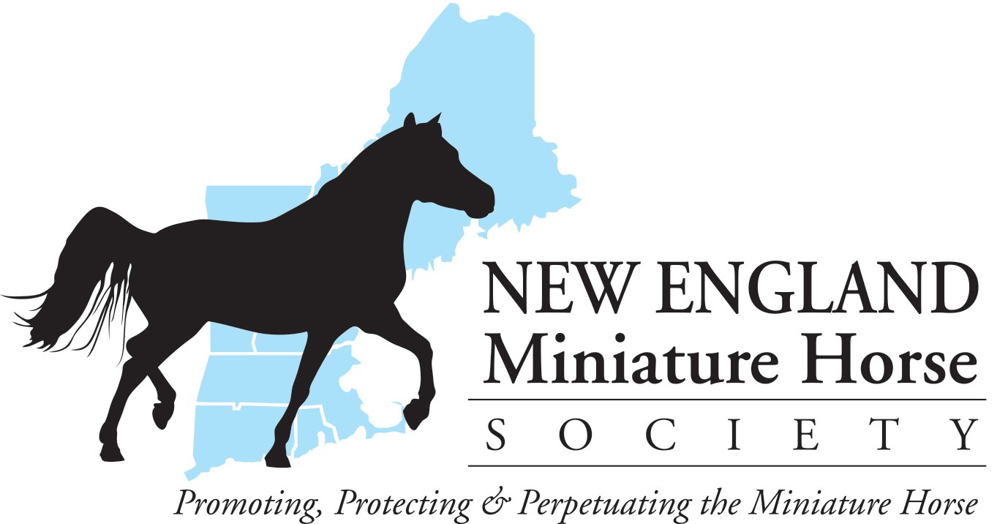
HEALTH REQUIREMETS
Please follow current CT State regulations and requirements for coggins and health papers. Please note that the requirements for out-of-state horses may differ from in-state horses. Consult with your veterinarian, and be sure to travel with the documents required by the states you are traveling through and showing in. Please have health forms available for inspection.

MEASURING
Measuring will be Thursday 5:00pm-7:00pm. Then 1 hour before the show starts and by special request, whenever possible throughout the day. Measuring will be conducted by the AMHR steward that is on the grounds for the AMHR show. At the time of measurement, please have available your health papers, including a negative Coggins for each horse to be shown, and an Official AMHA Certificate of Veterinary Inspection of Stallion for each senior stallion, if you have not already mailed or faxed these to the secretary. All horses must be measured before entering their first class, unless you have a permanent card. Hardship measuring will be by request and arranged with the show manager and AMHA office before the show.

Please be respectful of others and place trash in cans and scoop the poop!!
Judge evaluation cards will be available in the show office to be completed on a voluntary
basis.

THANK YOU FOR SHOWING WITH NEW ENGLAND MINIATURE HORSE SOCIETY IN 2026!!

Details X
A Moosup
V Moosup

0.3mi
.., Turn left onto Pond St

0.2mi
� Turn right onto River St

700ft
.., Turn left onto Sterling Hill Rd

2.3mi
.., Turn left onto Sterling Hill Rd

80ft
.., Turn left onto Plainfield Pike

1.7mi
� Turn right onto Newport Rd

1.3mi
� Turn right onto Woodland Rd

0.9mi

� Turn left onto Bailey Rd

4-t. 0.6mi

' I Turn left

� 450ft

,I Turn right

500ft
�� The destination is on your right
•

Falls Creek Farm

368 Bailey Rd, Moosup

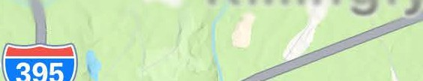
2:46.,
••
� .::J,

f ti:\
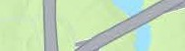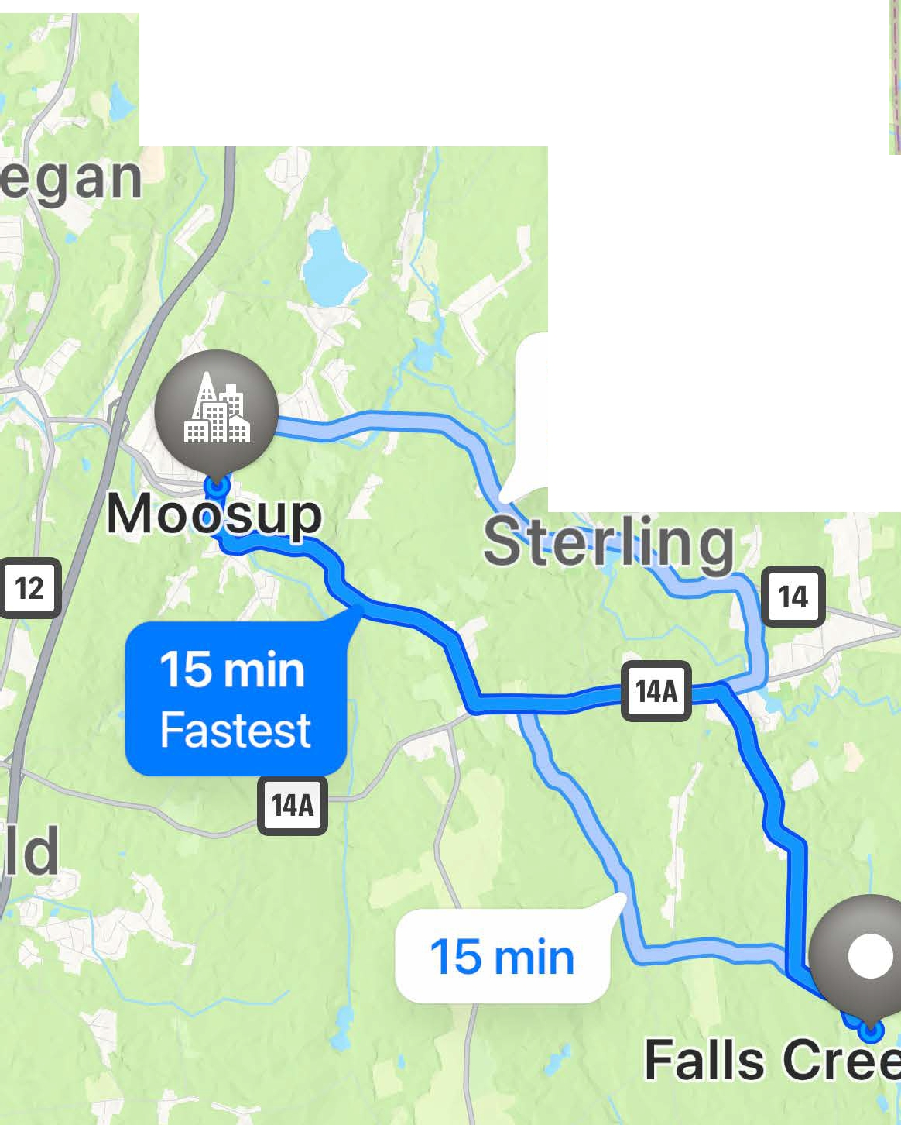
� Park
J Lake0
�
16min
Fewer turns
Ekonk
61°
AQI 35e

Directions X

