
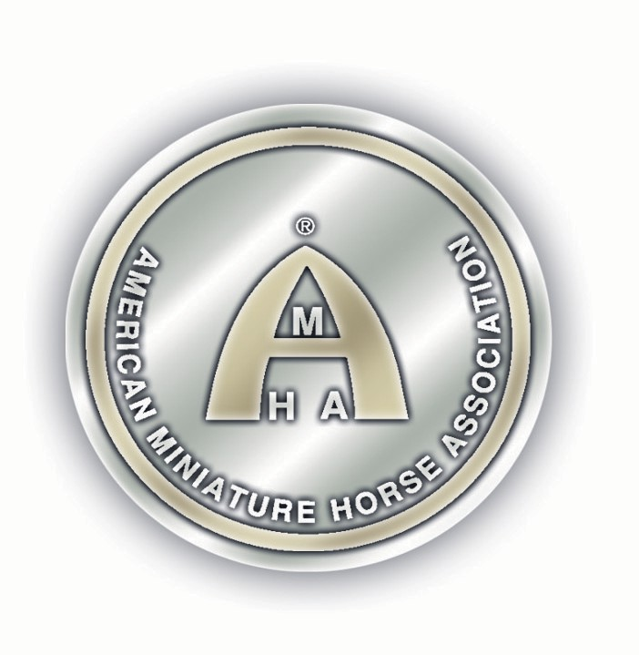

AMHA

TRI-STATE MINIATURE HORSE CLUB SPRING FLING
MAY 17, 2026
LORAIN COUNTY FAIRGROUNDS 2300 FAIRGROUNDS ROAD WELLINGTON. OH 44090

Start Time
Sunday-9:00am
Entry Deadline - MAY 8. 2026

Judges

JANICE SILVIO-SENIOR JUDGE-MI DENNIS SIENICKI-SENIOR JUDGE-NJ
TODD TRUSHEL-SENIOR JUDGE-PA

Steward
ROGER DAULTON

Show Manager:
DONNA PHILLIPS
2953 Mackville Road. Harrodsburg, KY 40330
859-265-1196 highmountai ngh�ahoo.com highmountainequestrianevents.com


PRE-ENTRY DEADLINE: MAY 8, 2026
ENTRIES RECEIVED AFTER THE POSTMARK OF MAY 8, 2026 WILL BE CHARGED AN EXTRA FEE OF $5.00 PER CLASS FOR OPEN AND AMATEUR CLASSES, IN ADDITION TO REGULAR CLASS FEES.
~This show is accredited and conducted under the 2026 rules and regulations of the American Miniature Horse Association (Alvarado, TX). All horses must be registered with the American Miniature Horse Association. All horses must be measured or present a valid measurement card.
~This show is triple judged for all divisions. Ribbons will be awarded for ist-6th place. Championship ribbons will be awarded for Grand Champions and Reserves, Junior and Senior Champions and reserves and Supreme Champion.

NO ARRIVALS BEFORE NOON, FRIDAY, MAY 15, 2026
Measuring:
Measuring will take place on Sunday May 17, 2026, starting one hour before show start time or at a scheduled time as requested in the show office. Exhibitor packets and numbers will be issued after measurement. A clear copy of your AMHA registration papers must be presented at time of measuring.
Entries:
All entry forms, copies of both sides of the AM HA registration papers for each horse, stallion inspection certificates (for senior stallions), copies of Amateur and /or Youth cards, and a check/money order must be submitted to the show office before you can show. Checks are to be made payable to: TSMHC. Entries post-marked after May 8, 2026, will be assessed a $5.00 fee per class. Any returned check will be assessed a $50.00 fee. No refunds will be given for any reason. Substitutions will be accepted without penalty. Gelding status must be reflected on papers or a show letter. Send in copy of Senior Stallion Verification form with entries. Gelding status must be listed on certificate.
Coggins/Health Papers: Coggins and Health papers are required at the facility. Please follow current Ohio state requirements for Coggins and Health papers. Please note that the requirements may be different for out-of-state horses vs. in-state-horses.
Amateur and Youth Classes:
All youth must have an AMHA Youth number to earn points towards National awards and titles. Age group is determined by the age of the exhibitor on January ist_ Youth card applications will be available in the show office or online. An AMHA Amateur card is required to participate in Amateur classes.
Amateur Card applications will be available in the show office or can be found online. Applications are
$5 more when submitted at a show.
Hard shipping:
Measurement for AMHA Hardship Application is available with advance notification by the applicant for such type measurement to the Show Manager. The designated time for Hardship Measurement will be held at a reasonable time before or immediately after a show day.

Responsibility:
It is the owner/handler/exhibitor's responsibility to be on time for classes. Announcements to the barn area are a management courtesy. Should a tack change be required, please make your requests at least 5 classes ahead oftime to the show staff. All dogs must be leashed while on the show grounds.


Shavings:
Must be ordered from the facility. No outside shavings allowed. Shavings will be delivered to your stalls before arrival.

Conduct:
Cruelty, abuse, or inhumane treatment of any horse in the show ring, barn, stalls or on the grounds is strictly prohibited and will not be tolerated by show management and shall result in disqualification of the horse and the exhibitor for the balance of the show. The offender will be barred from the show area for the duration of the show. The exhibitor will forfeit all trophies, ribbons, awards, and points for the show. The show manager will notify ASPC/AMHR of any such behavior when show results are reported. The use of stimulants or depressants or any drug affecting the showing of a horse is forbidden.
Special Needs Exhibitors:
If any special arrangements need to be made, please contact the show manager. Advance notice would be greatly appreciated. This show is open to all exhibitors regardless of mental or physical abilities.
Smoking: There wm be no smoking allowed in the barns, paddock, arena or show office.
Concession Stand:
The TSMHC is making every effort to have a concession stand at the show. But if unable to accommodate we will make other arrangements or allowances of time to get food from off the grounds.
Liability Statement:
Tri-State Miniature Horse Club, it's officers, officials and employees will not be responsible for any accident or loss which may occur to an exhibitor, spectator, guest, driver, groom, attendant, or other employee, animal or equipment at this show. THIS SHALL BE A CONDITION OF ENTRY TO THIS SHOW OR SHOW GROUNDS.
Emergencies:
Local Veterinarian and Farrier contact information will be posted at the show office and included in your show packet.
Mail Check and Entries to:
Donna Phillips, 2953 Mackville Road, Harrodsburg, KY 40330
You may also email entries to: highmountainqh@yahoo.com
Judge evaluation cards will be available in the show office to be completed on a voluntary basis.

LODGING:

Best Western Inn, 636 Griswold Road Elyria, OH 44035, 440-324-5050
Wingate by Wyndham Ashland, 1392 enterprise Pkwy, Ashland, OH 44805, 419-281-2900 Quality Inn & Suites, 4949 Park Avenue W, Seville, OH 44273,234-295-0017
Quality Inn Elyria, 739 Leona Road, Elyria, OH 44035, 440-387-4825
Quality Inn Brunswick Cleveland South, 1435 South Carpenter Road, Brunswick, OH 44212,330-293-0890
MainStay Suites Middleburg Heights Cleveland Airport, 7325 Engle Road, Middleburg Heights, OH 44130, 440-816-9300

DIRECTIONS TO THE SHOWGROUNDS:
