 |  | # |  | Deadline  MAY 8TH |  | Late Fee after MAY 8TH | Total
Office Fee Per Horse-TSMHC MEMBER  includes AMHA surcharge of $3 |  |  |  | X | $ 7.00
Non-member Office Fee $10.00/horse  includes AMHA surcharge of $3 |  |  |  | X | $ 10.00
Youth Class Fee |  |  |  | X | $ 15.00 | X $ 20.00
Amateur Class Fee |  |  |  | X | $ 20.00 | X $ 25.00
Open Class Fee |  |  |  | X | $ 20.00 | X $ 30.00
COOL Class Fee |  |  |  | X $10.00 |  | X $15.00
Shavings |  |  |  | X $10.00 |  | Must be  Pre-ordered
Camping/night/hook up |  |  |  | x | $40.00
Stalls $35/night |  |  |  | x $35.00
Showing From Trailer Fee-  Per Day/horse |  |  |  | X | $15.00 | X Days
Class Sponsorship | $10.00 per class or 6 classes for $50.00
Make checks to: TSMHC
Mail entries to: DONNA PHILLIPS, 2953 MACKVILLE ROAD, HARRODSBURG, KY 40330
or email to: highmountainqh@yahoo.com
Did you enclose a COPY of the following:  Registration Paper  Both Sides of Perm. Measurement Card Copy of Amateur &/or Youth Cards Entry Form Signed & Completed  Check or Money Order |  |  | For Office Use Only:  Date Received: Amount Enclosed: $ Check #:


Name of Farm Contact Person Mailing Address

TRI STATE MINIATURE HORSE CLUB
SPRING FLING
AMHA MAY 17, 2026
LORAIN COUNTY FAIRGROUNDS 2300 FAIRGROUNDS ROAD, WELLINGTON,
OH

City State Zip

( )

Phone #

E-Mail Address
Please Stall with:

NO ARRIVAL BEFORE NOON FRIDAY MAY 15, 2026

If you do not attend the show after mailing, emailing or texting entries you will be responsible for stall fees, office

fees, and shavings ordered.



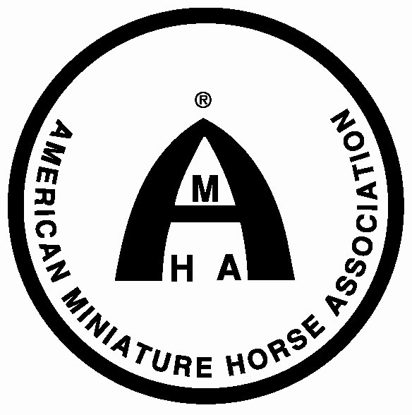

TSMHC SPRING FLING-AMHA

Must enclose a copy of registration papers, amateur and youth cards, and stallion certificates.All horses must be measured unless they have a permanent card.
If showing youth or amateur, and your name isn't on the registration papers, please list relationship to owner:

Show No. I  (Office Use) | Name of Horse | Exhibitor Name (s) | Class Number  (One class number per  box) |  |  |  | Reg. No. | Date of Birth | Sex | Height  (Office Use) | Registered Owners Names and City & State
 |  | 1)
 |  | 2)
 |  | 1)
 |  | 2)
 |  | 1)
 |  | 2)
 |  | 1)
 |  | 2)
 |  | 1)
 |  | 2)
 |  | 1)
 |  | 2)
This form must be signed in order to participate in the show. I hereby enter these horses in the classes listed above. By so entering, I agree to abide by and be bound by all rules and regulations of the Lorain County Fairgrounds and TSMHC. I agree to hold harmless the managers/staff and sponsors of the show from all liability in case of accident, theft, injuries or loss in any way associated with my participation in this event. My signature is proof that I have read, understand, and agree to accept this statement.

Signature of Exhibitor Signature of Exhibitor Signature of Parent or Legal Guardian

I certify that I am an amateur or youth as recognized by the rules of the AMHA.

Signature of Amateur & Am. # Signature of Amateur & Am. # Signature of Youth and Youth #

