ANNIE OAKLEY SHOW

JUNE 20-21, 2026
DARKE COUNTY FAIRGROUNDS GREENVILLE, OH
FOR MORE INFORMATION CONTACT SHOW MANAGER: DONNA PHILLIPS
highmountainqh@yahoo.com

Sponsorship Form

Class sponsorship - $10.00 per class or 6 for $50.00
The following information will be announced during the classes you sponsor and throughout the show.

Farm or Company Name:._ Contact Name: _ Address: Phone:�--�---------
E-mail: Web Address: _

Class Sponsored: ..:.#;______ Class Sponsored: ..:.:#
# # # #
# # # #

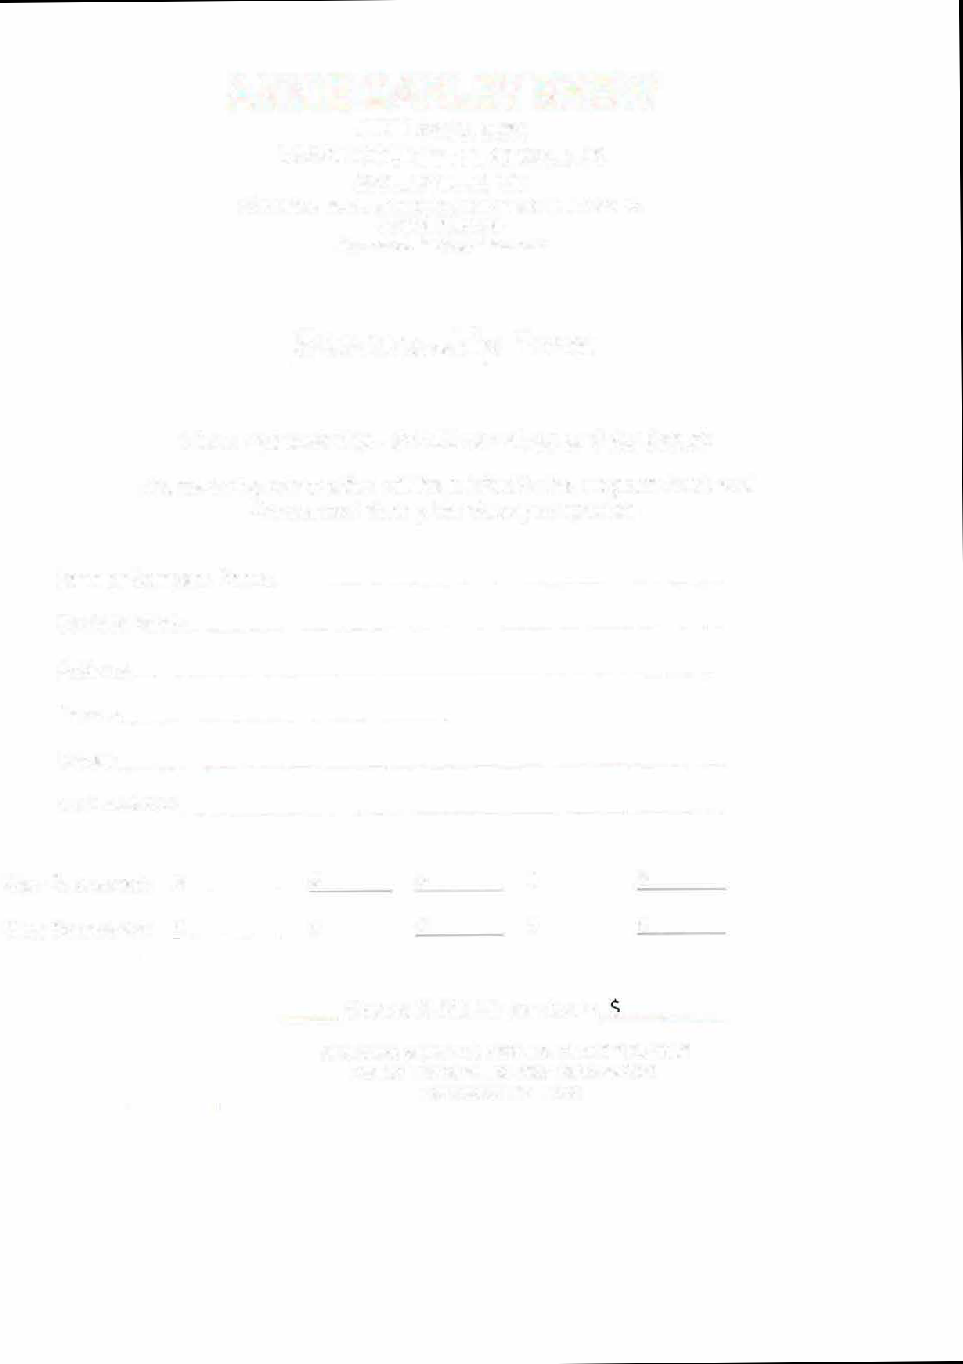
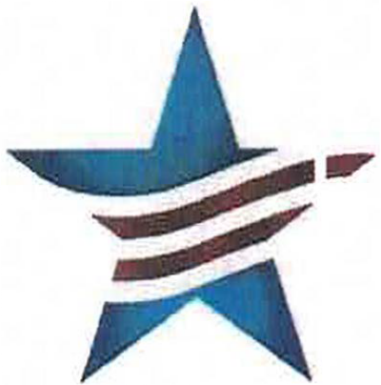
-- Classes @ $10.00 per class =-""-----
Make check payable to: AREA II SHETLAND PONY CLUB Mail to: Donna Phillips, 2953 Mackville Road Harrodsburg, KY 40330

