ASPC - AMHR - ASPR

ANNIE OAKLEY SHOW

JUNE 20-21, 2026
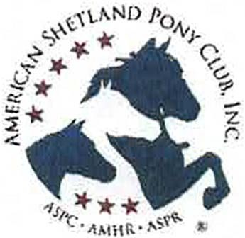
DARKE COUNTY FAIRGROUNDS. GREENVILLE. OH

Start Time: Saturday-9:00am (EST) Sunday-8:00am
-

Entry Deadline JUNE 11. 2026

JUDGES: CATHY BRUBAKER JENNY PIERUCKI MISSY NOYKOS

Steward
ROGER DAULTON

Show Manager:
DONNA PHILLIPS
2953 Mackville Road, Harrodsburg, KY 40330
859-265-1196 (cell) highmountainqh@yahoo.com

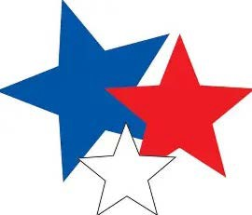
INFORMATION AT:
highmountainequestrianevents.com

Location:
Darke County Fairgrounds
800 Sweitzer Street, Greenville, OH 45331

Sponsored by: Darke County Horse andPonyClub
and

Area II Shetland Pony-Club

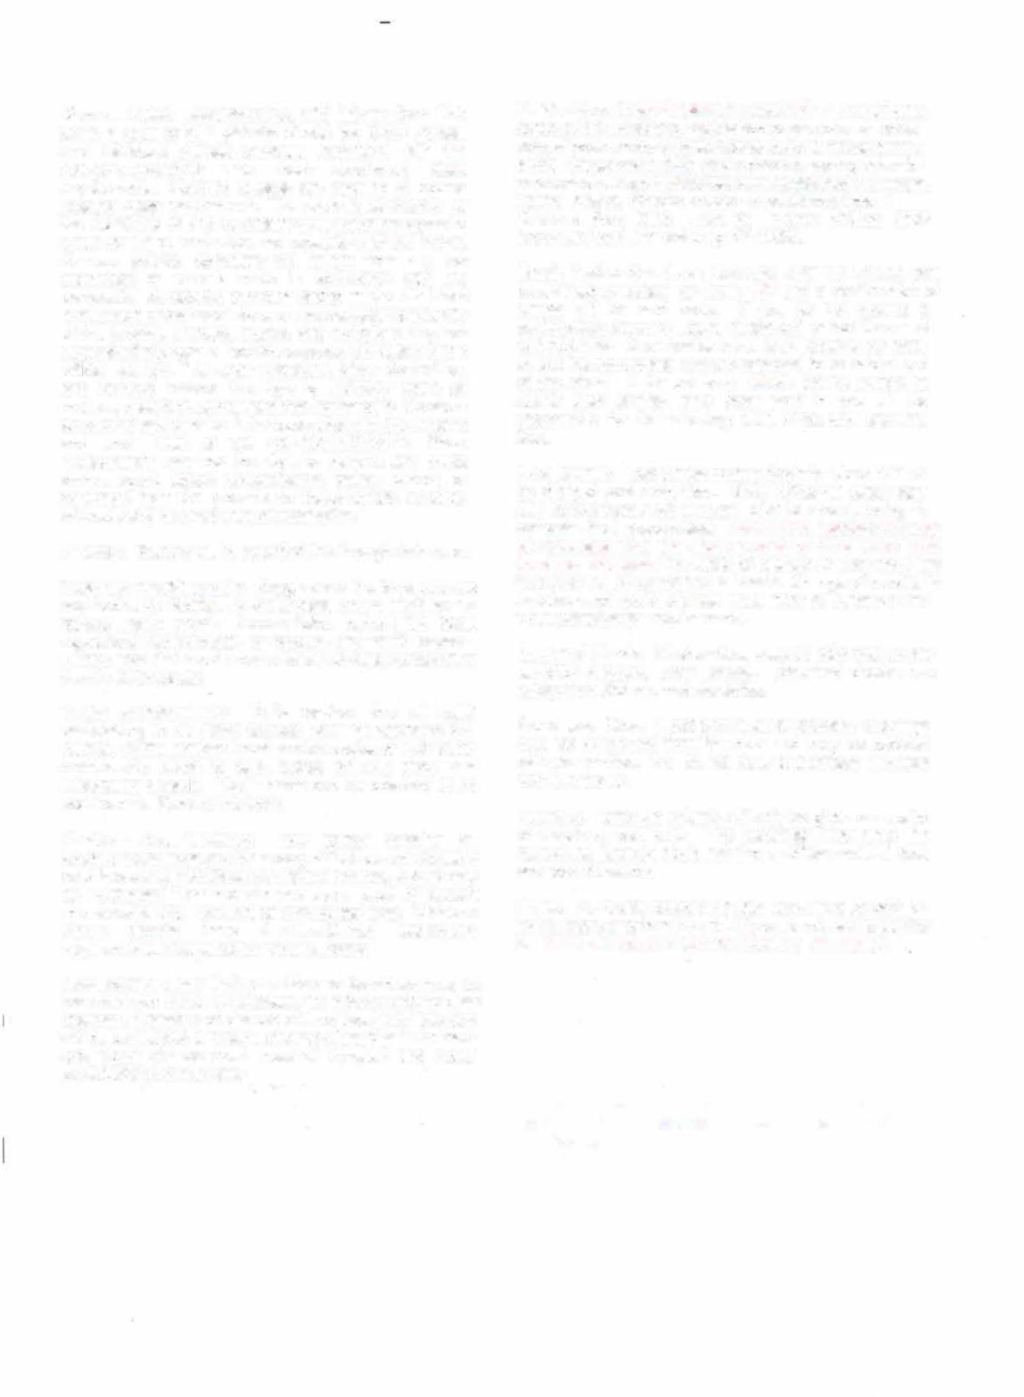
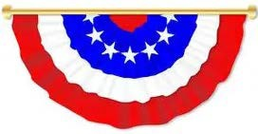
General Rules, Requirements, and Information: This show is open to all registered Shetlands, Show Ponies, and Miniature Horses currently registered with the ASPC/AMHR/ASPR who meet sanctioned class requirements. Nonrated classes are open to all equine meeting class requirements. This show is sanctioned by the ASPC/AMHR and by entering; all exhibitors agree to abide by the current rules and regulations of the ASPC. Owners, agents, exhibitors will refrain from any act committed or remark made in connection with the competition considered offensive and/or made with intent to influence or cast aspersions on the character or integrity of the judging. Owners, agents, and exhibitors may not approach the judges without the express permission of the official steward. The Show Manager, Show Committee, and Steward reserve the right to arbitrarily settle all matters, questions, and differences incidental to this show so long as said decision is in accordance with the by-laws and show rules of the ASPC/AMHR/ASPR. Show Management reserves the right to remove any horse owner, agent. stable representative, trainer, groom, or exhibitors from the grounds for inappropriate behavior without being held liable for compensation.
Awards: Ribbons will be awarded first through sixth place.
Coggins / Health papers: Coggins and Health papers are required at the facility. Please follow current OH State regulations requirements for coggins and health papers. Please note that requirements for out of state horses differ from in-state horses.
Youth Requirements: It is required that all youth participating in all riding classes wear an approved SEI helmet. Youth members must provide copies of their youth membership cards to earn points towards show and association awards. Youth cards can be obtained at no cost from the Steward the show.

Amateur Requirements: Any person entering an amateur class must provide a copy of their current Amateur card in order to participate In Amateur classes. A card may be purchased from the steward upon proof of current membership and payment of appropriate fees. Miniature Horse classes have Amateur/Owner relationship requirements. Please consult your rulebook.
Add/Scratch Class Policy: Adds and Scratches must be recorded with the show secretary 10 classes prior to class changes. Transfers of classes will not incur late fees and will be considered a "wash". Change of handler in Amateur and Youth classes must meet all Amateur and Youth participation requirements.
Entries Due: Entry deadline is June 11th All entry forms, copies of BOTH sides of registration paper-s of each horse, copy of youth and/or Amateur cards, copy of measurement cards if measured in 2025 and a check or money order for
payment of all appropriate fees sent to the Show Manager, Donna Phillips. Checks made payable to: Area II Shetland Pony Club. Mail to: Donna Phillips, 2953 Mackville Road, Harrodsburg, KY 40330.
Email, Text or Facebook Message Entries: Entries can
be emailed or texted by June 11th and a confirmation of entries will be sent back. If you do not receive a
confirmation within 24 hours please call or text Donna at 859-265-1196. Once entries have been received by email or text the appropriate fees are expected to be paid at end of the show. If for unknown reason you're unable to attend after entries have been sent in you will be responsible for the following: stall, office and shavings fees.

Post Entries: Late entries postmarked after June 111h will be charged post entry fees. Show office will close each day approximately 30 minutes prior to show starting to compete final preparations. Adds and Scratches must be recorded with the show secretary 10 classes prior to class changes. Transfers of classes will not incur late fees and will be considered a "wash". Change of handler in Amateur and Youth classes must meet all Amateur and Youth participation requirements.
Returned Check: All show fees must be paid prior to any exhibitor numbers being issued. Returned checks are subject to a $35 returned check fee.
Shavings: Straw is not permitted for bedding. Shavings may be purchased from the club and may be ordered with your entries. You do not have to purchase shavings from the facility.
Refunds: Entry fee refunds will only be given on receipt of veterinary certificate. The certificate must state the reason the horse(s) could not show. Office and stall fees are non-refundable.
Stalls: Per facility policy ANY stall used must be paid for. Do not store or groom in a stall if you do not wish to pay for it.
Stalls will be available for check In on Friday.


Measuring: All horses must be measured by steward or present a valid measurement slip documenting measurement by an official Steward within 60 days or present a permanent measurement card showing a measurement in the year of 2026. Please have your registration papers available for identification. Measurement times will be posted. Measuring Saturday 8:00am Sunday 7:00am
Gate Policy: It is the owner/handler/exhibitor's responsibility to be on time for classes. Announcements to barn area are a management courtesy. A TWO-MINUTE Gate will be observed. Timing will begin when the first horse enters the gate. Exhibitors are encouraged to have the equipment and/or equine in the warmup area to reduce tack change delays. Tack changes are limited to seven minutes. If you need a tack hold, please tell the Gate Person.
Dog Policy: All dogs MUST be confined or on a leash at ALL times. Al no time will excessively barking or running loose be tolerated. All dogs must be current with health requirements.
Emergency Information: Local emergency 911 for human emergency care. Contact information for Emergency Farrier & Veterinarian will be posted at the show throughout the barns.
Camping Reservations: Camping permits will be provided and are required to be displayed on the camping vehicle. All camping hook-ups must go through the show manager. Located on the facility is a dump station Facility policy requires that if you hook up to electric a!nywhere, you will be charged.
Motel & Camping Information:
Plenty of camping on grounds if you have RV see entry form!

Liability statement:
Area II Shetland Pony Club and Darke County Horse and Pony Club, its officers, officials and employees will not be responsible for any accident or loss wich may occur to an exhibitor, spectator, guest, driver, groom, attendant. or other employee, animal or equipment at this show. This shall be a condition of entry to this show or grounds.

Show Manager Donna Phillips
2953 Mackville Road
Harrodsburg, KY 40330
859-265-1196 (cell)
DIRECTIONS:
The Annie Oakley Show will be held on June 22-23, 2024 at the Darke County Fairgrounds, Greenville, OH.
Located between State Route 121 South and State Route 49 South.
Enter Gate #1 from State Route 49. Enter Gate #5 from STate Route 121.
Show grounds and barns located at south end of fairgrounds and are visible from the highways.

Motel Information:
Baymont lnn
851 Martin Street
937-548-3613

Holiday Inn Express 1195 Russ Road
937-548-1328

Quality Inn
1190 E Russ Road 937-316-5252

