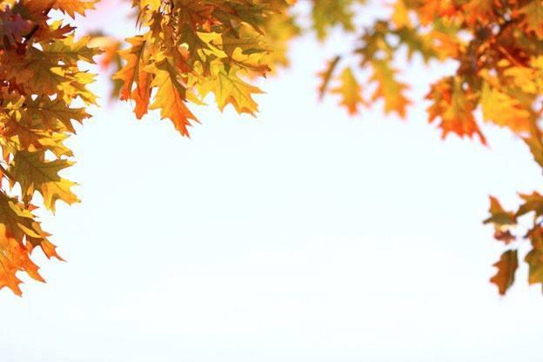

HCSC-ISEOA FALL FINALE
AMHR~ASPC~ASPR~NSPPR
October 9-10-11, 2026 Qualify for Nationals 2026 in one weekend
2 AMHR shows-1 ASPC show 4 Judges each show

Name of Farm Contact Person
HCSC – FALL FINALE-AMHR #1 -Sunday-OCTOBER 11  Entries Due by OCTOBER ^{1ST} | Fee |  |  | x |  | # |  | Total
Office Fee – Non-Refundable  Per Horse - Per Registry – Per Show AMHR/ASPC/ASPR/NSPPR | $ 15.00 |  |  | X
Youth (MUST be designated Youth Class) | Free |  |  | X
Adult – Amateur – Open – Stake-Cool | $ 45.00 |  |  | X
Unlimited classes per horse per registration division | $200.00 |  |  | X
Stall Fee is paid 1 time for 1 or ALL shows for the  weekend. Please mark what days you’re showing. | Friday Saturday Sunday
Stalls – Thursday – Monday (Limit 2 horses per stall) | $ 85.00 |  |  | X
Stalls – Early arrival | $ 15.00 |  |  | X
Shavings – MUST Pre-order – Non-Refundable | $ 10.00 |  |  | X
Camping Per Night – Electric only | $ 30.00 |  |  | X
 |  |  |  | X
LATE FEE – Per Horse – Per Registry – Per Show  Entries Received AFTER October ^{1ST} | $ 25.00
 |  |  |  | Total Due: $

Mailing Address

City State Zip
( )
X

Phone #
Make checks to: ISEOA
Mail entries to: Donna Phillips, 2953 Mackville Road, Harrodsburg, KY 40330
Email entries to: highmountainqh@yahoo.com Facebook Messenger entries to: Donna Phillips
Did you enclose a COPY of the following:  Registration Paper  Both Sides of Perm. Measurement Card Copy of Amateur &/or Youth Cards Entry Form Signed & Completed  Check or Money Order | For Office Use Only:  Date Received: Amount Enclosed: $ Check #:  Amount Due: $

E-Mail Address

Please Stall with:

If you do not attend the show after sending your entries in you will be responsible for stall fees, office fees, and shavings ordered.

SUNDAY

Sunday Entries

HCSC – AMHR #1-FALL FINALE
Friday Entries

Must enclose a copy of registration papers, amateur and youth cards and a copy of measurement card if measured in 2026.

Show No.  (Office Use) | Name of Horse | Exhibitor Name (s) | Class Number  (One class number per box) |  |  |  | Reg. No. | Date of Birth | Sex | Height  (Office Use) | Registered Owners Names and City & State
 |  | 1)
 |  | 2)
 |  | 1)
 |  | 2)
 |  | 1)
 |  | 2)
 |  | 1)
 |  | 2)
 |  | 1)
 |  | 2)
 |  | 1)
 |  | 2)

Statement of Responsibility and Liability Duplicate as needed.
This Agreement MUST be signed before participation in this event – ALL Exhibitors must have a signed release form!! This show is approved and conducted under ASPC/AMHR/ASPR rules and is open to AMHR horses registered with or recognized by the ASPC/AMHR/ASPR. By entering horses in this event, I hereby agree to abide and be bound by all ASPC/AMHR/ASPR rules. I also agree to hold harmless the Management and Sponsors of this event from all liability in case of accident, theft, injury, or loss, either to myself or persons with me, or to any animal in my care, custody, or control in any way associated with this event.

Signature of Owner / Agent / Exhibitor Signature of Owner / Agen / Exhibitor Signature of Parent or Legal Guardian
I certify that I am an amateur or youth as recognized by the rules of the AMHR – ASPC – ASPR.

Signature of Amateur & Am. # Signature of Amateur & Am. # Signature of Youth and Youth #

