|  |  |  |  |  |  |
| --- | --- | --- | --- | --- | --- |
|  | **#** | | **Deadline**  **MAY 28** |  | **Total** |
| **Office Fee Per Horse** |  | | X $8.00 |  |  |
| **YOUTH CLASS FEE** |  | | $20.00 |  |  |
| **AMATEUR CLASS FEE** |  | | X $25.00 |  |  |
| **OPEN CLASS FEE** |  | | X $30.00 |  |  |
| **COOL CLASS FEE** |  | | X $20.00 |  |  |
| **STAKE CLASS FEE** |  | | X $30.00 |  |  |
| **Shavings** |  | | X $9.00 | **Must be Pre-ordered** |  |
| **Stall**  **Stall cleaning fee if not cleaned by exhibitor** |  | | X $65.00  X $18.00 |  |  |
| **Flat fee (first 10 classes entered)** |  | | x $200.00 |  |  |
| **Camping must be arranged thru**  **fairgrounds 302-398-3269** |  | |  |  |  |
| **Late Fee** |  | | $25.00/horse | X horse |  |
| Show From Trailer/horse/day |  | | X $30.00 | X horse X day |  |
| **Class** $10.00 per class or  **Sponsorship** 6 classes for $50.00 |  | |  |  |  |
|  | | | | | |
| **Did you enclose a COPY of the following:**  Registration Paper  Both Sides of Perm. Measurement Card Copy of Amateur &/or Youth Cards Entry Form Signed & Completed  Check or Money Order | | **For Office Use Only:**  Date Received: Amount Enclosed: $ Check #:  **MEMBER** | | | |

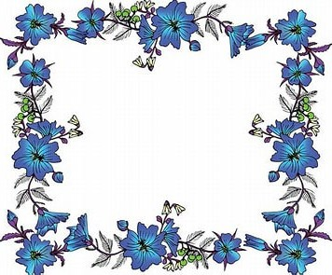

DELMARVA MINIATURE HORSE CLUB

DELAWARE STATE FAIRGROUNDS 18500 S DUPONT HIGHWAY HARRINGTON, DE 19952

**JUNE 7-8, 2025**

**Name of Farm Contact Person Mailing Address**

**City State Zip**

( )

**Phone #**

**E-Mail Address**

**Please Stall with:**

# Make checks payable to: DMHC

**Mail entries to:** DONNA PHILLIPS, 2953 MACKVILLE ROAD,

HARRODSBURG, KY 40330

or email entries to: [highmountainqh@yahoo.com](mailto:highmountainqh@yahoo.com)

**If you do not attend the show after mailing, emailing or texting entries you will be responsible for stall fees, office**

**fees, and shavings ordered.**

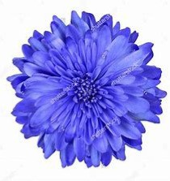 **DELMARVA MINIATURE HORSE CLUB ANNUALSHOW**

# Must enclose a copy of registration papers, amateur and youth cards and copy of measurement card if measured in 2025.

|  |  |  |  |  |  |  |  |  |  |  |  |
| --- | --- | --- | --- | --- | --- | --- | --- | --- | --- | --- | --- |
| **Show No.**  **(Office Use)** | **Name of Horse** | **Exhibitor Name (s)** | **Class Number**  (One class number per box) | | | | **Reg. No.** | **Date of Birth** | **Sex** | **Height**  **(Office Use)** | **Registered Owners Names and City & State** |
|  |  | 1) |  |  |  |  |  |  |  |  |  |
| 2) |  |  |  |  |
|  |  | 1) |  |  |  |  |  |  |  |  |  |
| 2) |  |  |  |  |
|  |  | 1) |  |  |  |  |  |  |  |  |  |
| 2) |  |  |  |  |
|  |  | 1) |  |  |  |  |  |  |  |  |  |
| 2) |  |  |  |  |
|  |  | 1) |  |  |  |  |  |  |  |  |  |
| 2) |  |  |  |  |
|  |  | 1) |  |  |  |  |  |  |  |  |  |
| 2) |  |  |  |  |

This form must be signed in order to participate in the show. I hereby enter these horses in the classes listed above. By so entering, I agree to abide by and be bound by all rules and regulations of Delmarva Miniature Horse Club and Delaware State Fairgrounds. I agree to hold harmless the managers/staff and sponsors of the show from all liability in case of accident, theft, injuries or loss in any way associated with my participation in this event. My signature is proof that I have read, understand, and agree to accept this statement.

Signature of Exhibitor Signature of Exhibitor Signature of Parent or Legal Guardian

# I certify that I am an amateur or youth as recognized by the rules of the AMHR – ASPC – ASPR.

Signature of Amateur & Am. # Signature of Amateur & Am. # Signature of Youth and Youth #