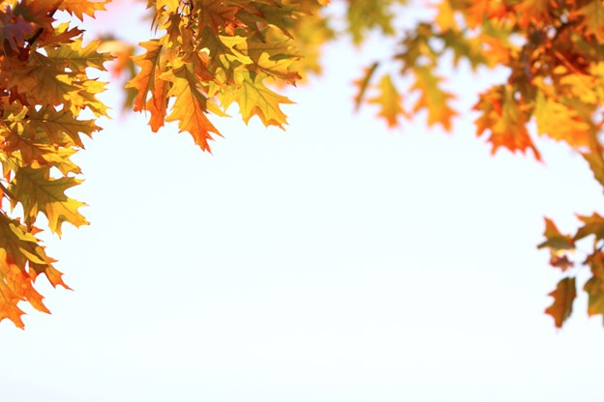

**HCSC-ISEOA FALL FINALE** AMHR~ASPC~ASPR~NSPPR October 10-11-12, 2025 Qualify for Nationals 2026 in one weekend 2 AMHR shows-1 ASPC show 4 Judges each show

|  |  |  |  |  |
| --- | --- | --- | --- | --- |
| **ISEOA – FALL FINALE-AMHR #2 - Sunday-OCTOBER 12**  **Entries Due by OCTOBER 2nd** | **Fee** | **x** | **#** | **Total** |
| **Office Fee – Non-Refundable**  Per Horse - Per Registry – Per Show AMHR/ASPC/ASPR/NSPPR | **$ 15.00** | **X** |  |  |
|  |  |  |  |  |
| **Youth** (**MUST** be designated Youth Class) | **Free** | **X** |  |  |
| **Adult – Amateur – Open - Stake** | **$ 45.00** | **X** |  |  |
| **Unlimited classes per horse per registration division** | **$150.00** | **X** |  |  |
| ***Stall Fee is paid 1 time for 1 or ALL shows for the weekend. Please mark what days you’re showing.*** |  | **Friday Saturday Sunday** |  |  |
| **Stalls –** Thursday – Monday(Limit 2 horses per stall) | **$ 85.00** | **X** |  |  |
| **Stalls – Early arrival** | **$ 15.00** | **X** |  |  |
| **Shavings – MUST Pre-order – Non-Refundable** | **$ 10.00** | **X** |  |  |
| **Camping Per Night –** Electric only | **$ 30.00** | **X** |  |  |
|  |  | **X** |  |  |
| **LATE FEE** – Per Horse – Per Registry – Per Show  **Entries Received AFTER October 2nd** | **$ 25.00** | **X** |  |  |

**Name of Farm**

**Contact Person**

**Mailing Address**

**City State Zip**

( )

**Phone #**

**E-Mail Address**

**Please Stall with:**

**If you do not attend the show after sending your entries in you will be responsible for stall fees, office fees, and shavings ordered.**

**Total Due: $**

**Make checks to:** ISEOA

**Mail entries to:** Donna Phillips, 2953 Mackville Road, Harrodsburg, KY 40330

**Email entries to:** highmountainqh@yahoo.com **Facebook Messenger entries to:** Donna Phillips

**For Office Use Only:**

Date Received:

Amount Enclosed: $

Check #:

**Amount Due: $**

**Did you enclose a COPY of the following:**

Registration Paper

Both Sides of Perm. Measurement Card

Copy of Amateur &/or Youth Cards

Entry Form Signed & Completed

Check or Money Order

**For Office Use Only:**

Date Received:

Amount Enclosed: $

Check #:

**ISEOA – AMHR #2-FALL FINALE**

***Sunday Show Entries***

***Sunday Show Entries***

**Must enclose a copy of registration papers, amateur and youth cards and a copy of measurement card if measured in 2025.**

|  |  |  |  |  |  |  |  |  |  |  |  |  |
| --- | --- | --- | --- | --- | --- | --- | --- | --- | --- | --- | --- | --- |
| **Show No.**  **(Office Use)** | **Name of Horse** | **Exhibitor Name (s)** | **Class Number**  (One class number per box) | | | | **Reg. No.** | **Date of Birth** | **Sex** | | **Height**  **(Office Use)** | **Registered Owners Names and City & State** |
|  |  | 1) |  |  |  |  |  |  |  |  | |  |
| 2) |  |  |  |  |
|  |  | 1) |  |  |  |  |  |  |  |  | |  |
| 2) |  |  |  |  |
|  |  | 1) |  |  |  |  |  |  |  |  | |  |
| 2) |  |  |  |  |
|  |  | 1) |  |  |  |  |  |  |  |  | |  |
| 2) |  |  |  |  |
|  |  | 1) |  |  |  |  |  |  |  |  | |  |
| 2) |  |  |  |  |
|  |  | 1) |  |  |  |  |  |  |  |  | |  |
| 2) |  |  |  |  |

**Statement of Responsibility and Liability Duplicate as needed.**

This Agreement ***MUST*** be signed before participation in this event – ***ALL Exhibitors*** must have a signed release form!! This show is approved and conducted under ASPC/AMHR/ASPR rules and is open to AMHR horses registered with or recognized by the ASPC/AMHR/ASPR. By entering horses in this event, I hereby agree to abide and be bound by all ASPC/AMHR/ASPR rules. I also agree to hold harmless the Management and Sponsors of this event from all liability in case of accident, theft, injury, or loss, either to myself or persons with me, or to any animal in my care, custody, or control in any way associated with this event.

Signature of Owner / Agent / Exhibitor Signature of Owner / Agen / Exhibitor Signature of Parent or Legal Guardian

**I certify that I am an amateur or youth as recognized by the rules of the AMHR – ASPC – ASPR.**

Signature of Amatuer & Am. # Signature of Amatuer & Am. # Signature of Youth and Youth #