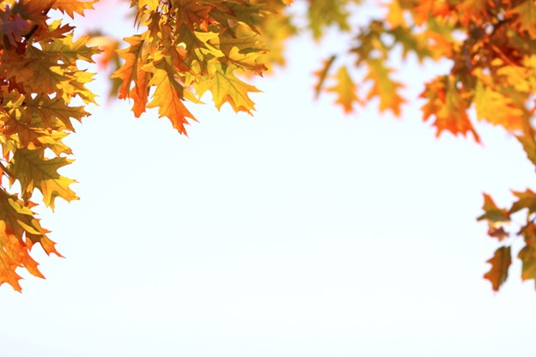

***Saturday Evening***

***PIZZA PARTY***

**HCSC-ISEOA FALL FINALE** AMHR~ASPC~ASPR~NSPPR October 10-11-12, 2025 2 AMHR shows-1 ASPC show 4 Judges each show

***SATURDAY EVENING***

***YEAR END AWARDS***

**QUALIFY FOR NATIONALS 2026 IN ONE WEEKEND**

**2221 North Memorial Drive, New Castle, IN**

**Entries Due – October 2, 2025**

**October 10th - Friday**

**HCSC – AMHR Fall Finale Show**

***Diane Gaines-OH Michelle Chilson-OH Jenny Pierucki – MI Janice Silvio-MI***

**October 11th - Saturday**

**ISEOA – ASPC / ASPR Fall Finale Show**

***Jason Prince-IL Roger Daulton-OH Dennis Mason-KY Melissa Downs-OH***

**October 12th - Sunday**

**ISEOA – AMHR Fall Finale Show**

***Jason Prince-IL Roger Daulton-OH Dennis Mason-KY Melissa Downs-OH***

**Show Steward – Randy Martin**

**Show Manager – Donna Phillips**

859-265-1196 - highmountainqh@yahoo.com

2953 Mackville Road Harrodsburg, KY 40330

Information at: highmountainequestrianevents.com

**General Rules, Requirements, and Information:** This show is open to all registered Shetlands, Show Ponies, and Miniature Horses currently registered with the ASPC/AMHR/ASPR who meet sanctioned class requirements. Nonrated classes are open to all equine meeting class requirements. This show is sanctioned by the ASPC/AMHR and by entering; all exhibitors agree to abide by the current rules and regulations of the ASPC. Owners, agents, and exhibitors will refrain from any act committed or remark made in connection with the competition considered offensive and/or made with intent to influence or cast aspersions on the character or integrity of the judging. Owners, agents, and exhibitors may not approach the judges without the express permission of the official steward. The Show Manager, Show Committee, and Steward reserve the right to arbitrarily settle all matters, questions, and differences incidental to this show so long as said decision is in accordance with the by-laws and show rules of the ASPC/AMHR/ASPR. Show Management reserves the right to remove any horse owner, agent, stable representative, trainer, groom, or exhibitors from the grounds for inappropriate behavior without being held liable for compensation.

**Coggins / Health papers:** Coggins and Health papers are required at the facility. Please follow current IL State regulations requirements for coggins and health papers. Please note that the requirements for out-of-state horses differ from in-state horses.

**Youth Requirements:** It is required that all youth participating in all riding classes wear an approved SEI helmet. Youth members must provide copies of their youth membership cards to earn points for show and association awards. Youth cards can be obtained at no cost from the Steward at the show.

**Amateur Requirements:** Any person entering an amateur class must provide a copy of their current Amateur card in order to participate in Amateur classes. A card may be purchased from the steward upon proof of current membership and payment of appropriate fees.

**Add/Scratch Class Policy:** Adds and Scratches must be recorded with the show secretary 15 classes prior to class changes. Transfers of classes will not incur late fees and will be considered a “wash”. Change of handler in Amateur and Youth classes must meet all Amateur and Youth participation requirements.

**Entries Due: Entry deadline is October 2nd** . All entry forms, copies of BOTH sides of registration papers of each horse, copy of youth and/or Amateur cards, copy of measurement cards if measured in 2025 and a check or money order for payment of all appropriate fees sent to the Show Manager, Lisa Leonard and checks made payable to ISEOA. Mail to: Donna Phillips, 2953 Mackville Road, Harrodsburg, KY 40330.

**Email or Facebook Message Entries:** Entries can be emailed or messaged by **October 2nd** and confirmation of entries will be sent back. If you do not receive confirmation within 24 hours, please call or text Donna at 859-265-1196. Once entries have been received by email or messenger the appropriate fees are expected to be paid at the end of the show. If for an unknown reason you’re unable to attend after entries have been sent in you will be responsible for the following: stall, office and shavings fees.

**Post Entries:** Late entries postmarked after **October 2nd** will be charged post entry fees. The show office will close each day approximately 30 minutes prior to show each morning to complete final preparations.

**Lennie’s Pee Wee Liberty**: Pee Wee Liberty is a Non-Rated AMHR Class with Special Rules – Age 7 & under, AMHR only, helpers of any age, catch lead stays on, can use same horse more than once. Ownership is not required.

**Returned Check:** All show fees must be paid prior to any exhibitor numbers being issued. Returned checks are subject to a $50 returned check fee.

**Refunds:** Entry fee refunds will only be given on receipt of veterinary certificate. The certificate must state the reason the horse(s) could not show. Office, shavings and stall fees are non-refundable.

**Stalls:** Per facility policy **ANY** stall used must be paid for. Do not store or groom in a stall if you do not wish to pay for it. Please use the entry form to indicate if you wish to be stalled with someone or in a particular area. We will try to accommodate requests on a first-come basis. Any issues with stalls please contact Barn Manager – Lennie Bertrand

**Measuring:** All horses must be measured by steward or present a valid measurement slip documenting measurement by an official Steward within 60 days or present a permanent measurement card showing a measurement in the year 2025. Please have your registration papers available for identification. Measuring will begin Thursday – 5:00 p.m. – 7:00 p.m. and each morning beginning at 7:00 a.m. and throughout the show as needed.

**Gate Policy:** It is the owner/handler/exhibitor’s responsibility to be on time for classes. Announcements to the barn area are a management courtesy. Exhibitors are encouraged to have the equipment and/or equine in the warmup area to reduce tack change delays. **If you need a tack hold, please tell the Gate Person.**

**Dog Policy:** All dogs **MUST** be confined or on a leash at ALL times. At no time will excessively barking or running loose be tolerated. All dogs must be current with health requirements.

**Emergency Information:** Local emergency 911 for human emergency care. Human first aid kit will be available in the show office. Contact information for Emergency Farrier & Veterinarian will be posted at the show throughout the barns.

**Camping:** Camping permits will be provided and are required to be displayed on the camping vehicle. All camping hookups must go thru the show manager. There are also campers available to rent on site. Contact Rebecca Baker at Henry County Saddle Club 765-524-2400

**Motel:**

Steve Alford All-American Inn

21 Executive Drive

New Castle, IN 47362

765—593-1212

**Directions:**

Please check your GPS for directions to:

Henry County Saddle Club

2221 North Memorial Drive

New Castle, IN 47362

**Any questions concerning directions you can contact:**

Donna Phillips 859-265-1196 or Lennie Bertrand – 815-530-7578

**Henry County Saddle Club**

**2221 North Memorial Drive**

**New Castle, IN 47362**

**765-524-2400**

**Directions if coming from the west (Indianapolis) or East :** Take 70, then take exit 123 onto SR-3 toward New Castle. Go thru New Castle. Facility is on the left just outside of town.

**Directions if coming from the north:** Take 67 to SR-3 toward New Castle.

