### ASPC~AMHR

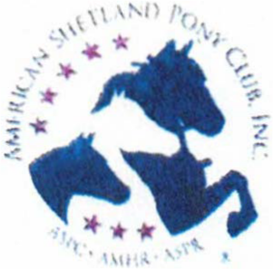

A SUMMER BREEZE

**HOSTED BY: ORANGE BLOSSOM MINIATURE HORSE CLUB**

# JULY 7, 2024

SCHAGHTICOKEFAIRGAOUNDS 69 STILLWATER BRID6€ ROAD SCHAGHTICOKE, NY 12154

## Start Time

Saturday-8:00om

**Entry Deadline** -JUNE 30, 2024

**Judges**

# RONALD BARTHOLOMEW- WORLD JUDGE

**LARRY THURBER**

## Steward

MARK RANDALL

## Show Manager:

DONNA PHILLIPS

2953 Mackville Road, Harrodsburg, KY 40330

859-265-1196 [highmountainqh@yahoo.com](mailto:highmountainqh@yahoo.com)

This show is accredited and conducted under the 2024 rules and regulations of the American Shetland Pony Club (ASPC/AMHR). All horses must be registered with ASPC/AMHR. All horses must be measured by the AMHR Steward or present a measurement slip documenting measurement by an official AMHR steward within the last 60 days or a permanent card that has been validated in the year 2024. Youth and /or amateur numbers must be provided. Valid AMHR registration, current Coggins (within 1 year), and health certificate within 30 days on out­ of-state horses must be provided. Foals six months and younger do not require a Coggins when traveling with the mare. In-State horses must present current Coggins (within 1 year) and rabies certificate.

PREMI UMS: Ribbons will be awarded for first through sixth place in each class, Grand/Reserve Champions and Champion/Reserve horses.

#### GENERAL RULES

Evidence of any inhumane treatment to a horse in or out of the show ring will result in disqualification of that horse and that exhibitor for the balance of the show, as well as all of that horse's and exhibitor's points, ribbons, trophies, plus all entry, stall, and office fees being forfeited.

Dogs must be on a leash.

**Trash:** Trash cans are available on the grounds and near the arena. Please dispose of your trash properly.

Members of Orange Blossom Miniature Horse Club, exhibitors, representatives and spectators agree to conduct themselves professionally and utilize good sportsmanship at all times.

Violators are subject to removal from the grounds.

**Dress Code:** Absolutely no torn jeans, sweat pants, shorts, t-shirts, tank tops or open toed shoes are allowed in the ring. This includes all ring personnel. Proper show attire will be worn by exhibitors in the ring at all times, including Championship and Grand classes. Please refer to your rulebook, especially for Showmanship classes.

**Judge Evaluations:** Evaluation forms will be available in the show office to be completed on a voluntary basis.

**Return Check Fee:** There will be a $35.00 charge for any returned check by NEMHS.

**Refunds:** No refunds will be given on any office fees or stall fees. Refunds will only be given on receipt of veterinary certificate stating the reason the hose was unable to show. Substitutions will be accepted without penalty. This show will run rain or shine. There is an indoor arena.

#### ENTRIES

Please pre-enter if possible. Entries postmarked or emailed after the deadline are subject to an additional fee. Pre-entries must be accompanied by payment. Refunds will be made with a veterinarian's certificate or a physicians' letter. Please see refunds above.

Provided you have pre-entered, classes may be added on the day of the show without penalty.

Please take care to fill out the entry form completely and carefully, and include your signature and amateur/youth numbers where indicated.

A copy of both sides of your horses' AMHR/ASPC registration papers must accompany the entry form and be presented at measuring.

Youth and Amateur exhibitors must hold current AMHR Youth or Amateur cards, or may apply with the show steward the day of the show. Please include your youth and amateur numbers on the entry form, and enclose a copy of your current youth and amateur cards with your entry form. Amateurs must also sign the entry form where indicated. AMHR youth is an individual that has not attained eighteen years of age as of December l51 of the current competition year.

**Gelding Status:** It must be reflected on the registration papers in order for the horse to be shown in any AMHR classes.

**Leased Horses:** They must be on record with ASPC/AMHR. Include a copy of the lease authorization form, and indicate on your entry that the horse is leased.

**Driving Horses:** All driving horses are to be driven with a bit. Orange Blossom Miniature Horse Club requests that all Youth drivers wear an ASTM approved helmet. Helmets are required in youth roadster classes.

**Stalls:** Stalls: NO more than 2 horses per stall. Stallions over 2 years must be stalled separately. Pre-ordered shavings will be available for pick up when you arrive at the facility. You may bring your own shavings. Stall waste is to be dumped in designated areas only. Contact the show manager to make stall arrangements. Stalls are a minimum of 10' x 10'. Stalls will be available for Thursday arrival after 10:00am for an extra fee of $10.00/stall.

**PA System:** This is a courtesy provided by the facility. If it does not function, show management will work with the facility to ensure this service, but it is not guaranteed. We will be using a two-minute gate call. Please check in with the gate manager when arriving at the ring so that the show can continue at a steady pace. It is each exhibitor's responsibility to be at the gate on time. Should a tack change be required please request this at the gate at least five classes ahead of the needed time.

**Concession Stand:** There will not be a concession stand available at the grounds. There are however places to get food close to the grounds.

COOL: Special needs individuals are always welcome to participate in all AMHR shows. If special arrangements are needed please try to contact the Show Manager ahead of time, if possible.

**CAMPING:** There are sites available with water, sewer, and electric. There are also sites with electric only. Sites available on a first com-first serve basis.

**Discounted fees:** Discounted fees are for members of the New England Miniature Horse Society.

### HEALTH REQUIREMENTS

Out of State horses must have a negative Coggins report within one year, a health certificate within 30 days, and proof of a rabies vaccination. In State horses must have negative Coggins within two calendar years and proof of a rabies vaccination. Consult with your veterinarian, and be sure to travel with the documents required by the states you are traveling through and showing in. Please have your health forms available at time of measuring.

#### MEASURING

Measuring starts one hour before show time, and by special request, whenever possible throughout the day. Show start time will be 8:00am each day. Measuring will be conducted by the AMHR Show Steward. At the time of measurement, please have available your registration papers, rabies certificate, and a current negative Coggins for each horse to be shown. All horses must be measured or present a validated permanent card before entering their first class.

**Address:** 69 Stillwater Bridge Road, Schaghticoke, NY 12154

**FEES:**

Open classes $30.00 (NEMHS member and non-member) Amateur classes $20.00-NEMHS member, $25.00 non-member Youth classes $17.00-NEMHS member, $20.00 non-member (Note: youth in an open class pays the Open Fee}

COOL classes $15.00 (NEMHS member and non-member)

Flat fee for first 12 classes-pre entry $160.00, post entry $180.00-MEMBERS OF NEMHS ONLY Post entry fee per horse $20.00/horse

Office fee per horse $10/horse/show

Stalls: $60.00/Weekend-NEMHS member $70.00/weekend-non-member Camping: $35.00/night, $60.00/weekend. $25.00/additional night.

# Please be respectful of others and place trash in cans and scoop the poop!!

**THANK YOU FOR SHOWING WITH ORANGE BLOSSOM MINIATURE HORSE CLUB IN 2024!!!**



In the town of Schaghticoke, NY to the fairgrounds

**To 69 Stillwater Brk:lge Rd Done Schaghticoke**

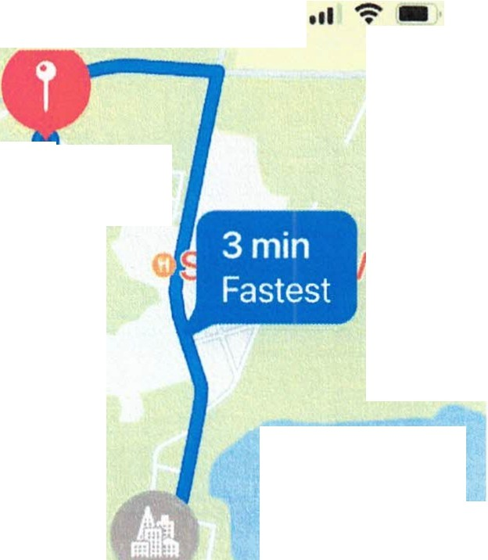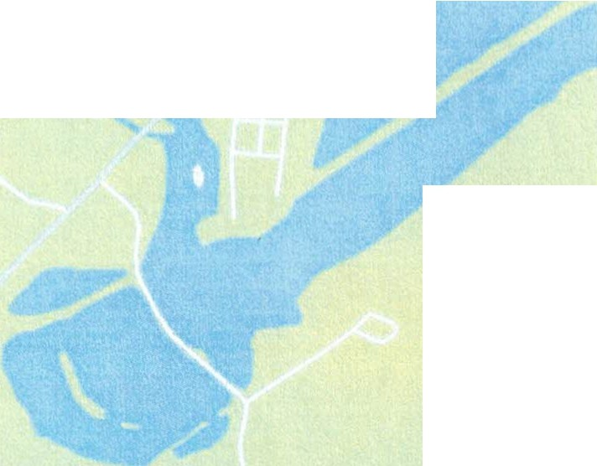

**69 Stillwater Bridge Rd**

**al**

***Electric Lake***

**Schagifticoke**

Schaght,co,e NY Llnited States

.._ **50 ft**

I Turn left onto Ma,n St

.._ **0.8mi**

I Turn lef1onto Stillwater Bridge Rd

**0.2mi**

., Tllrn left onto Schaghticoke

**fdngrounds**



**69 Stillwater Bridge Rd**

69 Stik,ater Br•dge Rd, Schaght,co<e. N" 12154. United

0

States \nnw VIFW DR

'i:. sCHA 370

AQI 34 **e·E**

From the South/West

To Schaghticoke, NY Done To Schaghticoke, NY Done

....,....... ....,.......... ......., ........,..u,,...,....,, ..........

**Lexington**

Lexington, KY, United States **137mi**

ij; Take exit 26 to merge onto 1-81

r **0.4mi**

,

.,

toward Harrisburg

Turn right onto N Broadway Rd

**3.0mi**

Turn left to merge onto I 64 East toward Ashland, Knoxville

**600ft** To Schaghticoke, NY

Keep left to merge onto 1-81 North

toward Harrisburg, Hagerstown **51 mi**

**w**

Keep left on I- 78 E toward

New Jersey

Done

**2.4mi**

Take exit 111 on the left to merge onto 1-64 E toward Winchester

**0.3mi**

Keep right to merge onto 1-81 **56mi**

***r***

North toward Harrisburg, Take exit 29 to merge onto 1-287

Hagerstown toward I -80, Morristown

,

Ashland '

**0.3mi**

**0.5mi**

Keep left to merge onto 1-287

'

**169mi**

**w**

Take exit 59 to merge onto 1-77 N toward I 79, Parkersburg

Keep left to merge onto 1-81 North North toward 1-80, US-202 North

toward Harrisburg

**39mi**

Keep left on 1-287 N toward 1-87

**1.9mi 78mi**

ij;

Keep left on 1-81 N toward

NJ-17 '

**w** Take exit 104 on the right to merge

onto 1-79 N toward Clarksburg

Allentown, I-78 **8.0mi**

ij; Continue onto 1-87 N toward New York State Thruway North, NY-17

**148mi 19mi**

ijj Take exit 148 on the right to merge ij; Take exit 89 on the right to merge onto I 68 E toward Cumberland onto I-78 E toward Allentown

North

**14mi**

**w**

Keep left on 1-87 N

To Schaghticoke, **NV Done**

To Schaghticoke, NY Done

**98ml**

**:ow** ,akc exit 23 to merge onto Byp<1 s

US-9W toward Troy, 1-787 **9.0mi**

**0** Take exit 9E to merge onto NY-7

**0.3mi**

' Keep !ell to merge onto 1-787

, East toward Troy, Bennington

North toward Troy Downtown **1.0mi**

Albany

Tum left onto Tenth St

**9.0mi**

**0** TaKe exit 9E to merge onto Y7 **r 3.Smi**

East toward Troy, Bennington

.,

**1.0mi**

Turn left onto -enth St

,.. **3.5mi**

Tum right onto Northern Dr

**450ft**

,

,

Turn left onto Leversee Rd

Turn 11ght onto Norther 1 Dr

.,

**450ft**

.,

**8.7mi**

Tum left onto School St

T ,rn lett onto Leversee Rd G) **50ft**

**t** Arrive at the destination

*(,)*

**8.7ml**

- urn left onto Schoor St **Schaghticoke**

**50ft** Schaghticoke, NY United States

**From the North-West**

**Buffalo To** Schaghticoke **Done To** Schaghticoke Done

Buffalo, NY United States

**8.9mi 76ml**

**r 250ft *(40G***

.,

Continue onto US-400 S

**w** Keep left on 1-81 N

Turn right onto Perkins Dr toward Syracuse

.,.. **4.1mi**

**200ft** Take the exit onto US-20A, NY-78 **2.5mi**

urn left onto S Elmwood Ave ***ii*** Keep right on 1-88 E

**0.2ml** toward Albany

**700ft** Keep left onto US-20A East

'

**112mi**

**cE'.** Take exit 24 onto US-20

, ***r* 35mi**

***t*** Take a slight right turn onto toward Warsaw Church St

toward Duanesburg

**800ft**

Keep left to merge onto 1-190

**2.3mi**

,..

Keep right onto Perry Rd

,..

**0.2mi**

.,

Turn right onto US Hwy 20 Con

South toward 1-90, NY-5 West

**5.1 mi**

Take exit 54 61 on the right to

,..

Turn nght onto Mt Morris Rd

**7.3mi**

toward US-20, Duanesburg

**350ft**

Turn right to merge onto Turn left onto Western rpke

nierqe onto 1-90 W toward Erie 1-390 South

**15mi**

**1.6mi 56mi *t*** Take a slight right turn toward 1-87,

Tukc exit 54 on the right to merge **w** Keep left or I 86 E toward New York State Thruway

**s**

onto NY-400 S toward NY-16, NY-352 Cornirig

W•st Seneca

**76mi**

**7.4mi**

**0** Take e, it 7 to merge onto NY-7

**East to rna 100 *to:* ,oas**

To Schaghticoke Done

**7.4mi**

**0** Take exit 7 to merge onto NY 7

,

East toward Troy, Cohoes

**4.6mi**

Turn left onto Tenth St

**r+ 3.Smi**

,

Turn nght onto Northern Dr

**450ft**

,

Turn left onto Leversee Rd

**8.7mi**

Turn left onto School St

0 **50ft**

**t** Ar ·ive at the destination

**Schaghticoke**

Schaghticoke, N) United States